Online Cloud-Enabled Bookstore System

##### A Project Report

**Submitted by:**

##### Kaustubh Naithani, Prashant Kumar, Dhruva Malik, Mohammed Bilal

**University Roll Number 20BCS4000, 20BCS4363**

**20BCS3976**

#### in partial fulfillment for the award of the degree of BACHELOR OF ENGINEERING

##### IN

**COMPUTER SCIENCE (Big Data and Analytics)**

##### Under the Supervision of: Ms. Pooja Jaiswal



**CHANDIGARH UNIVERSITY, GHARUAN, MOHALI - 140413,**

##### PUNJAB

**MONTH & YEAR May 2023**

|  |  |  |
| --- | --- | --- |
| **Table of Contents** |  |  |
| Title Page | 1 |
| Table of contents | 2 |
| List of tables | 3 |
| List of figures | 4-5 |
| Candidate Declaration | 6 |
| Abstract | 7 |
| Acknowledgement | 8 |
| **1. Introduction** | **9-18** | **1** |
| 1.1 Problem Statement | 9-10 |  |
| 1.2 Problem Formulation | 10-11 |  |
| 1.3 Background and motivation | 11-12 | 1 |
| 1.4 Objectives | 12-13 |  |
| 1.5 Report Organization | 13 |  |
| 1.6 Software tool Specifications | 13-16 |  |
| 1.7 Hardware and Software Requirements | 16-17 |  |
| 1.8 Feasibility of the Project | 17 |  |
| 1.9 Scope of Project | 18 | 5 |
| **2. Literature Review** | **19-30** |  |
| **3. System Design** |  |  |
| 3.1 DFD Diagram | 31 |  |
| 3.2 Use case diagram | 32-33 |  |
| 3.3 User Interface Design | 33-50 |  |
| **4. Methodology** |  |  |
| 4.1 Methodology Used | 51-52 |  |
| 4.2 Tools | 52 |  |
| 4.3 Requirements | 53 |  |
| 4.4 Implementation and Testing | 53-55 |  |
| **5. Conclusion** | **56-57** |  |
| **Future Scope** | **58-59** |  |
| **References** | **60** |  |

# List of Tables

|  |  |  |
| --- | --- | --- |
| **Table name** | **Table Description** | **Page No.** |
| **Table 1** | Existing Features and the features that can be  implemented | 30 |
| **Table 2** | Login | 53 |
| **Table 3** | Adding New Books | 54 |
| **Table 4** | Adding New category | 54 |
| **Table 5** | Ordering Book | 55 |

**List of Figures**

|  |  |  |
| --- | --- | --- |
| **Figure name** | **Figure Description** | **Page No.** |
| Figure 2.1 | System Architecture Diagram | 22 |
| Figure 2.2 | UML Design | 23 |
| Figure 2.3 | Comparing Different Cloud Platforms | 26 |
| Figure 2.4 | Cloud Market Share | 28 |
| Figure 3.1 | DFD Diagram | 31 |
| Figure 3.2 | Use Case Diagram | 32 |
| Figure 3.3 | Home Page | 33 |
| Figure 3.4 | Welcome Page 1 | 34 |
| Figure 3.5 | Welcome Page 2 | 34 |
| Figure 3.6 | Welcome Page 3 | 35 |
| Figure 3.7 | Shopping Cart | 35 |
| Figure 3.8 | Payment Options | 36 |
| Figure 3.9 | Payment Screen | 36 |
| Figure 3.10 | Order Confirmation Screen | 37 |
| Figure 3.11 | Customer Login | 37 |
| Figure 3.12 | Customer Sign in | 38 |
| Figure 3.13 | Manager Login | 38 |
| Figure 3.14 | Manager sign up | 39 |
| Figure 3.15 | My Bookstore | 39 |
| Figure 3.16 | View Book Items | 40 |
| Figure 3.17 | Add Book Items | 40 |
| Figure 3.18 | Edit Book Items | 41 |
| Figure 3.19 | Delete Book Items | 41 |
| Figure 3.20 | Order History | 42 |
| Figure 3.21 | Images Folder | 42 |
| Figure 3.22 | Server on amazon AWS | 43 |
| Figure 3.23 | EC2 Instance Details | 43 |
| Figure 3.24 | The Storage Details | 44 |
| Figure 3.25 | Security Details | 44 |

|  |  |  |
| --- | --- | --- |
| Figure 3.26 | Connecting To Instance Using RDP | 45 |
| Figure 3.27 | Password for Windows Server | 45 |
| Figure 3.28 | Networking  Information of the instance | 46 |
| Figure 3.29 | Server Statistics of The Instance | 46 |
| Figure 3.30 | Database of Customer Details | 47 |
| Figure 3.31 | Table of Customer Login Credentials | 47 |
| Figure 3.32 | List of all books in database | 48 |
| Figure 3.33 | Table of Manager Login Credentials | 48 |
| Figure 3.34 | Database of Books ordered | 49 |
| Figure 3.35 | Table of individual user bookstore | 49 |

## CANDIDATE'S DECLARATION

We, ‘Kaustubh Naithani’, ‘Dhruva Malik’, ‘Prashant Kumar’, student of ‘Bachelor of Engineering in CSE Big Data Analytics’, session: 2023, Department of Computer Science and Engineering, Apex Institute of Technology, Chandigarh University, Punjab, hereby declare that the work presented in this Project Work entitled ‘Online Cloud Enabled Bookstore System’ website is the outcome of our own bona fide work and is correct to the best of our knowledge and this work has been undertaken taking care of Engineering Ethics. It contains no material previously published or written by another person nor material which has been accepted for the award of any other degree or diploma of the university or other institute of higher learning, except where due acknowledgment has been made in the text.

# ABSTRACT

The project "Virtual Mouse Using Hand Gestures" explores the innovative application of computer vision and machine learning technologies to create an intuitive and efficient human-computer interaction system. In an era where the traditional computer mouse and keyboard interfaces are evolving, this project focuses on offering a novel and more natural means of interacting with computers.

This research project leverages computer vision algorithms and a camera-based input system to detect and interpret hand gestures, translating them into corresponding mouse movements and actions on a computer screen. Through the integration of machine learning models, our system is capable of recognizing a variety of hand gestures, such as pointing, clicking, scrolling, and dragging, enabling a seamless and touchless interaction experience.

The results of this project demonstrate the potential for more immersive and hands-free computer control, making it particularly relevant in scenarios where traditional input devices are impractical or cumbersome, such as in virtual reality, presentations, and accessibility applications. Challenges encountered during development, including gesture recognition accuracy and real-time responsiveness, are discussed and solutions proposed.

"Virtual Mouse Using Hand Gestures" project represents an exciting advancement in the realm of human-computer interaction, showcasing the capabilities of modern computer vision and machine learning technologies. The system's successful implementation suggests a promising future for touchless computer control, bringing us one step closer to a more intuitive

and convenient computing experience.

# ACKNOWLEDGEMENT

We would like to express our deep and sincere gratitude to our Project respected in charge Dr. Monica Singh for giving us the opportunity to do the project and providing valuable guidance throughout this research. Our project mentor’s dynamism, vision and exquisite efforts have deeply inspired us. She taught us the methodology to carry out the research and to present the research work as clearly as possible. It was a great privilege for us to study and work under their guidance. We owe the completion of my project to our project Mentor for her continuous support and guidance.

# Chapter 1 Introduction

In the rapidly evolving landscape of human-computer interaction, the fusion of technology and intuitive user interfaces has paved the way for innovative solutions that bridge the gap between humans and machines. One such groundbreaking development is the integration of gesture control technology into everyday computing devices. This project delves into the captivating realm of gesture-based control, aiming to revolutionize the conventional interaction with laptops. By leveraging the capabilities of a laptop's built-in camera, we have harnessed the power of hand gestures to provide an innovative, more natural, and convenient means of navigating and commanding a laptop's functions.

The proliferation of laptops in our daily lives has drastically changed the way we work, communicate, and entertain ourselves. However, the conventional methods of interaction, primarily through the touchpad, keyboard, and external mouse, can sometimes be cumbersome and limited. Users often find themselves tethered to these input devices, leading to concerns of discomfort, repetitive strain, and restricted mobility.

Gesture control technology, on the other hand, offers an exciting alternative to these traditional input methods. It enables users to communicate with their laptops using natural hand movements, eliminating the need for physical contact with the device. This technology, initially popularized by gaming consoles and smartphones, has gained widespread attention for its potential to enhance user experience in a variety of applications.

The primary objective of this project is to design and implement a system that allows users to control a laptop's functions by performing specific hand gestures in front of the laptop's camera. By doing so, we aim to achieve the following:

**Enhanced User Experience:** To offer a more intuitive and engaging interaction with laptops, making tasks like scrolling, zooming, and navigating through applications as simple as a wave or a pinch.

**Improved Accessibility:** To cater to a broader range of users, including those with physical limitations or disabilities, by providing an alternative, more accessible input method.

**Efficiency and Convenience:** To streamline common tasks, such as controlling media playback, presentations, and gaming, through natural hand gestures, reducing the reliance on external input devices.

### Problem Statement

In the contemporary landscape of human-computer interaction, the ubiquity of conventional input devices like the mouse and keyboard has underscored the need for more intuitive and accessible means of computer control. These traditional input methods, while effective for various tasks, can be cumbersome, limiting the potential for natural interaction with computers, particularly in applications where touchless control is beneficial.

The project "Virtual Mouse Using Hand Gestures" recognizes the limitations of the current interface paradigms and aims to address this challenge. The primary problem at hand is the need to bridge the gap between the physical world and digital computing systems, making human-computer interaction more intuitive, responsive, and versatile. To do this, we seek to develop an innovative solution that leverages the capabilities of computer vision and machine learning to interpret and respond to hand gestures as a means of controlling a computer.

Key issues that this project aims to tackle include:

1. Inefficiency of Traditional Input Devices: Conventional input devices like the mouse and keyboard may not provide the most efficient means of interaction, especially in applications where fine-grained control or rapid input is essential.

2. Accessibility and Inclusivity: Many individuals, including those with physical disabilities, face challenges in using traditional input devices. A touchless, gesture-based system can offer a more inclusive and accessible solution.

3. Natural Interaction: Humans are accustomed to interacting with their environment using gestures, and extending this natural interaction to computing can lead to more intuitive and user-friendly experiences.

4. Innovation and Potential Applications: The project recognizes that modern technology opens the door to new possibilities in virtual reality, gaming, presentations, and accessibility applications. However, existing solutions often fall short of delivering a seamless experience.

The proposed solution, by creating a virtual mouse using hand gestures, aims to provide a more intuitive and accessible means of interacting with computers. It seeks to overcome the challenges of gesture recognition accuracy, real-time responsiveness, and seamless integration with existing software and systems. Ultimately, this project strives to offer a compelling alternative to traditional input devices, addressing the identified problems and contributing to the evolution of human-computer interaction for the benefit of a broad user base.

### Problem Formulation

Certainly, here's a problem formulation for the project "Virtual Mouse Using Hand Gestures" presented in bullet points:

1. **Problem Context:**

The project is situated in the context of modern human-computer interaction (HCI) systems, where traditional input devices, such as mice and keyboards, dominate.

2. **Primary Problem Statement:**

The primary problem is the need to create a more intuitive, efficient, and accessible method of interacting with computers, addressing the limitations of conventional input devices.

3. **Challenges and Sub-Problems:**

1. Gesture Recognition Accuracy:

Sub-Problem: Ensuring accurate recognition of a wide range of hand gestures.

Rationale: Accurate gesture recognition is essential to provide a seamless and frustration-free user experience.

ii. Real-Time Responsiveness:

Sub-Problem: Achieving real-time responsiveness in translating detected gestures into computer actions.

Rationale: Delayed or laggy responses would hinder the effectiveness and naturalness of the interaction.

iii. Integration with Existing Software and Systems:

Sub-Problem: Ensuring seamless integration of the virtual mouse system with a variety of software applications and operating systems.

Rationale: Compatibility is crucial to make the system practical for everyday computer use.

iv. Accessibility and Inclusivity:

Sub-Problem: Designing the system to be accessible and inclusive, accommodating individuals with physical disabilities.

Rationale: Inclusivity is a critical consideration to ensure that the system benefits a diverse user base.

v. Natural Interaction Design:

Sub-Problem: Creating an intuitive user interface and interaction model that mirrors natural human gestures.

Rationale: A design that feels natural and intuitive is essential for user acceptance and ease of use.

vi. Fine-Grained Control:

Sub-Problem: Enabling users to perform fine-grained and precise control, such as pixel-level movements and detailed actions.

Rationale: Fine control is necessary for a wide range of applications, including graphic design and 3D modeling.

vii. User Training and Learning Curve:

Sub-Problem: Minimizing the learning curve for users, making the system accessible to individuals of varying technical backgrounds.

Rationale: An overly complex system could deter potential users.

viii.Potential Applications:

Sub-Problem: Identifying and developing use cases for the virtual mouse system, such as gaming, virtual reality, presentations, and accessibility applications.

Rationale: Demonstrating the versatility and value of the system in real-world scenarios.

The project aims to deliver a functional virtual mouse system capable of intuitive, accurate, and responsive computer control via hand gestures. The system should be adaptable for a range of applications and accessible to a broad user base.

The successful development of the virtual mouse system would represent a significant advancement in HCI, potentially revolutionizing how individuals interact with computers. The project could open doors to innovative applications in fields such as virtual reality, gaming, accessibility, and more. It has the potential to enhance the accessibility and usability of computers for individuals with disabilities.

4. **Constraints and Limitations:**

Resource constraints: Limited access to specialized hardware, software, and expertise.

Technical limitations: Challenges in achieving real-time responsiveness and universal compatibility.

Ethical considerations: Data privacy and potential concerns related to gesture tracking.

### Background and motivation

The "Virtual Mouse Using Hand Gestures" project emerges against the backdrop of a rapidly evolving landscape in human-computer interaction (HCI). The traditional input devices, such as the mouse and keyboard, have been the cornerstone of computer control for decades. However, as technology advances and new possibilities emerge, there is a growing need for more intuitive, natural, and accessible means of interacting with computers.

The project draws inspiration from the limitations of traditional input devices. While these devices have served us well, they often fall short in accommodating the evolving demands of modern computing. They can be cumbersome and fail to provide the fine-grained control or seamless interactions that users increasingly desire.

Moreover, the motivation for this project is rooted in the pursuit of accessibility and inclusivity. It acknowledges that individuals with physical disabilities often face significant challenges when using traditional input devices. By developing a system that responds to hand gestures, the project strives to break down barriers and offer a touchless interface that can be harnessed by a diverse user base, including those with disabilities.

Furthermore, the project taps into the innate desire for a more natural and intuitive means of interacting with technology. Humans are accustomed to using hand gestures in their daily lives to communicate and manipulate objects. The potential for translating these natural movements into computer control is not only appealing but also aligns with the inherent desire for technology to adapt to human behavior rather than the other way around.

The growing interest in virtual reality, gaming, and immersive computing experiences provides additional motivation. These fields demand interfaces that can support natural, gesture-based interactions, enhancing the sense of immersion and engagement.

In summary, the "Virtual Mouse Using Hand Gestures" project is motivated by the need to address the limitations of traditional input devices, advance accessibility, and tap into the innate desire for natural and intuitive interactions with technology. It is fueled by the evolving demands of modern computing, the pursuit of inclusivity, and the potential for innovation in fields like virtual reality and gaming. As technology continues to progress, this project seeks to offer a compelling alternative, shaping the future of human-computer interaction and opening doors to more intuitive, accessible, and versatile computing experiences.

### Objectives

The "Virtual Mouse Using Hand Gestures" project encompasses various features aimed at revolutionizing human-computer interaction through an innovative, gesture-based control system:

1. Gesture Recognition Capabilities: The system boasts advanced computer vision algorithms for accurately recognizing and interpreting a diverse array of hand gestures, including pointing, clicking, dragging, scrolling, and more.

2. Real-Time Responsiveness: Emphasizing instantaneous translation of detected gestures into corresponding computer actions, ensuring a seamless and natural interaction experience.

3. Machine Learning Integration: Project utilizes machine learning models to continually improve gesture recognition accuracy, adapting to diverse user movements and enhancing system performance over time.

4. Compatibility and Integration: Designed to seamlessly integrate with various software applications and operating systems, allowing users to employ the virtual mouse across different computing environments.

5. Accessibility and Inclusivity: It prioritizes accessibility features, catering to individuals with physical disabilities, offering an inclusive means of interacting with computers.

6. Natural Interaction Design: Focuses on developing an intuitive and user-friendly interface that mirrors natural human gestures, reducing the learning curve for users.

7. Fine-Grained Control: Enables users to achieve precise and fine-grained control, critical for applications requiring detailed input, such as graphic design or 3D modeling.

8. Use Case Exploration: The project actively explores diverse applications in gaming, virtual reality, presentations, and accessibility scenarios, showcasing the versatility and potential of the virtual mouse system.

9. Iterative Development and User Testing: Embraces an iterative design approach, involving continuous user feedback and testing to refine and enhance the system's usability and performance.

10. Potential for Innovation: Holds promise in revolutionizing human-computer interaction, potentially opening doors to novel applications and reshaping the landscape of computing interfaces.

These features collectively form the backbone of the "Virtual Mouse Using Hand Gestures" project, aiming to create a more natural, accessible, and versatile means of interacting with computers, pushing the boundaries of traditional input systems and shaping the future of human-computer interaction.

### Report Organization

This report is divided into 5 chapters. Chapter 1 is the introduction of the project includes problem statement, objectives and motivation. In Chapter 2, types of bookstore systems are reviewed and compared with the proposed system. Chapter3, describe the overall proposed architecture and methods. The user interface design and different diagrams are included in this chapter as well. Chapter 4, explain the methodology and tools used and also the testing phases. Chapter 5, discuss the conclusion for it.

### Software tool Specifications:

##### Python

Python is a high-level, versatile, and dynamically-typed programming language that has gained immense popularity in the world of software development and data science. Known for its clean and readable syntax, Python is celebrated for its simplicity, making it an ideal language for both beginners and experienced developers. Python was created by Guido van Rossum and first released in 1991, and it has since become a staple in various domains. It supports multiple programming paradigms, including procedural, object-oriented, and functional programming, and boasts a vast standard library that facilitates a wide range of tasks. With its rich ecosystem of libraries and frameworks, Python is widely used for web development, scientific computing, data analysis, artificial intelligence, and automation. Python's community-driven development and open-source nature have led to a robust and ever-expanding ecosystem that continues to evolve and address the demands of modern software development.

##### Numpy

NumPy, short for Numerical Python, is a fundamental library in the Python ecosystem that empowers numerical and mathematical computing. It provides support for large, multi-dimensional arrays and matrices, along with an extensive collection of high-level mathematical functions to operate on these arrays. NumPy is a cornerstone of scientific and data-oriented computing, and it plays a pivotal role in countless projects, including scientific research, data analysis, machine learning, and more.

NumPy's active community ensures that it remains a robust, reliable, and continuously evolving library. Its versatility and performance make it an indispensable tool for any project that involves numerical and mathematical computations in Python, cementing its status as a foundation of the scientific and data computing world.

##### Mediapipe

Mediapipe is an open-source, cross-platform framework developed by Google Research for building machine learning-based applications that process and understand media data, including audio, video, and image inputs. This versatile library plays a pivotal role in the "Virtual Mouse Using Hand Gestures" project, providing the foundation for accurate gesture recognition and tracking.

Key Features and Components:

1. Media Processing Pipeline: At the heart of Mediapipe is its media processing pipeline, which allows developers to create complex data processing workflows in a modular and extensible manner. This flexibility is crucial for accommodating various components required for hand gesture recognition.

2. Ready-Made Solutions: Mediapipe offers a collection of pre-built solutions for common media processing tasks, which significantly expedites the development process. In the context of the project, these solutions can be leveraged for key tasks like hand tracking and landmark detection.

3. Media Data Support: The library handles various types of media data, including image, audio, and video, making it versatile for a wide range of applications. In this project, it is primarily used for processing image data captured by cameras to detect and interpret hand gestures.

4. Cross-Platform Compatibility: Mediapipe is designed to work across different platforms, including mobile devices, desktop computers, and edge devices. This cross-platform compatibility ensures that the virtual mouse system can be deployed on a wide array of computing environments.

5. Efficient ML Inference: One of the standout features of Mediapipe is its support for efficient machine learning inference. It optimizes neural network models for real-time performance, a critical aspect for the virtual mouse system's responsiveness.

6. Customization and Extensibility: Developers have the flexibility to customize and extend the library's capabilities. This is particularly useful in tailoring the gesture recognition model to specific requirements of the project.

Gesture Recognition with Mediapipe:

Mediapipe's Hand module, a part of the MediaPipe Hands solution, plays a central role in the project's gesture recognition process. It offers real-time hand tracking and keypoint estimation, allowing the system to precisely locate and track the user's hand in a video feed. Using landmark detection, the library can identify key points on the hand, such as fingertips, knuckles, and palm, with exceptional accuracy. This information is vital for recognizing and interpreting gestures. By analyzing the relative positions and movements of these landmarks, the system can distinguish between various gestures, such as pointing, clicking, scrolling, and more. Mediapipe's ability to operate in real-time is particularly advantageous, ensuring that detected gestures translate into computer actions instantly, providing a seamless and natural interaction experience.

Community and Support:

Mediapipe benefits from an active and supportive community of developers and researchers. This community-driven approach ensures that the library is continually improved and updated, making it a robust and reliable choice for projects that require media data processing and understanding.

##### OpenCV

OpenCV, which stands for Open Source Computer Vision Library, is an open-source computer vision and machine learning software library. It is designed to provide a comprehensive set of tools, algorithms, and libraries for computer vision applications, making it one of the most widely used and respected resources in the field of computer vision. OpenCV was initially created by Intel in 1999 and has since gained immense popularity in both the academic and industrial communities. It is maintained and developed by a collaborative team of researchers and engineers, making it a constantly evolving and improving resource.

Key Features and Capabilities:

OpenCV offers a broad range of features and capabilities, which make it a valuable tool for various applications, including image and video processing, object detection, facial recognition, gesture recognition, robotics, and more. Some of its key features include:

Image Processing: OpenCV provides a wide range of functions for image manipulation, including resizing, filtering, and transformation.

Computer Vision Algorithms: The library includes numerous pre-built algorithms for tasks such as object tracking, feature detection, and image stitching.

Applications:

OpenCV's versatility and wide array of functions have made it a go-to choice for a variety of applications:

Facial Recognition: OpenCV has been used extensively in facial recognition systems for security and identification purposes.

Object Detection: It is widely used in object detection and tracking in fields like autonomous vehicles, surveillance, and robotics.

Medical Imaging: OpenCV is applied in medical image analysis, including the detection of anomalies in X-rays and MRIs.

##### PyautoGUI

PyAutoGUI is an open-source Python library that provides an easy and intuitive way to automate graphical user interface (GUI) interactions. It allows users to control the mouse and keyboard, simulate keypresses, and perform a variety of GUI tasks programmatically. PyAutoGUI is platform-independent, making it a valuable tool for automating tasks and testing on different operating systems.

Key Features and Capabilities:

Mouse Control: PyAutoGUI enables users to control the mouse cursor's position, move it, and simulate mouse clicks. This feature is essential for automating tasks that involve navigating and interacting with on-screen elements.

Keyboard Control: The library allows for the simulation of keypresses, key releases, and keyboard shortcuts. Users can type text, trigger hotkeys, and automate text entry.

Mouse Drags: PyAutoGUI supports mouse drag operations, enabling users to interact with UI elements that require click-and-drag actions.

Screen Resolution Independence: PyAutoGUI is resolution-independent, meaning that it can work across various screen sizes and resolutions, making it adaptable to different systems.

Applications:

PyAutoGUI finds applications in a wide range of use cases, including:

Automated Testing: It is commonly used for testing GUI applications by automating user interactions and ensuring software functionality and reliability.

Repetitive Tasks: Users can automate routine and repetitive tasks, such as data entry, form filling, or file manipulation, to save time and reduce human error.

GUI Scripting: Developers use PyAutoGUI for creating scripts that interact with GUI-based applications and perform actions that would typically require manual intervention.

Accessibility Features: PyAutoGUI can assist users with limited mobility by automating mouse and keyboard actions, making computers more accessible.

PyAutoGUI is a valuable Python library for automating GUI interactions, simplifying tasks that involve mouse and keyboard interactions with the screen. Its easy-to-use functions make it accessible to both developers and non-developers, and its versatile

applications extend to software testing, data entry, accessibility features, and more. As the library continues to improve and adapt to evolving technologies, it is expected to remain a critical tool for GUI automation in various industries.

### Hardware And Software Requirement:

#### Hardware Requirement:

Processor: 2.4 GHz Intel i5 9th gen or equivalent or new Disk Space: 10GB or more

#### Software Requirement:

Operating System: No particular OS required because Python and its Library are platform independent.

Software: Visual Studio Code/Python IDLE

Programming Language: Python

Libraries: Numpy, OpenCV, MediaPipe, PyautoGUI

### Feasibility of the Project

The feasibility of controlling a laptop using hand gestures is high. The technology required to do this already exists, and there are a number of commercial and open source hand gesture control systems available. However, there are still some challenges that need to be addressed before hand gesture control can be widely adopted for laptop use.

One challenge is the accuracy and reliability of hand gesture recognition. Hand gesture recognition systems can be affected by a number of factors, such as lighting, background noise, and the user's own hand movements. It is important to develop hand gesture recognition systems that are robust to these factors in order to ensure a good user experience.

Another challenge is the development of user interfaces and interaction logic that are specifically designed for hand gesture control. Traditional graphical user interfaces (GUIs) are designed to be controlled with a mouse or touchpad, and they can be difficult to use with hand gestures. It is important to design GUIs and interaction logic that are intuitive and easy to use with hand gestures.

Finally, hand gesture control systems need to be integrated with existing laptop

hardware and software. This can be a challenge, as laptop manufacturers typically do not design their hardware and software with hand gesture control in mind.

However, there are a number of ways to integrate hand gesture control systems with existing laptops, such as using external cameras and sensors, or by developing software that can be installed on any laptop. Despite the challenges, there are a number of reasons why hand gesture control is a feasible way to control laptops. Hand gesture control is a natural and intuitive way for humans to interact with computers. It can also be more efficient than using a mouse or touchpad for some tasks. For example, it can be much faster to open a program by making a simple hand gesture than by having to move the cursor to the program icon and click it.

Hand gesture control can also be beneficial for people with disabilities who have difficulty using a mouse or touchpad. For example, people with quadriplegia can use hand gesture control to control their laptops without having to use their hands. Overall, the feasibility of controlling a laptop using hand gestures is high. The technology required to do this already exists, and there are a number of commercial and open source hand gesture control systems available. While there are still some challenges that need to be addressed, such as the accuracy and reliability of hand gesture recognition, the benefits of hand gesture control make it a promising technology for laptop use.

Here are some specific examples of how hand gesture control can be used to control laptops:

1. Move the cursor: Users can move the cursor by simply moving their hand in the air. This can be useful for tasks such as selecting text or moving objects around the screen.
2. Click the mouse: Users can click the mouse by making a snapping gesture with their hand. This can be useful for tasks such as opening and closing programs, or selecting menu items.
3. Scroll: Users can scroll by moving their hand in a circular motion. This can be useful for tasks such as scrolling through long documents or web pages.
4. Zoom in and out: Users can zoom in and out by making a pinching gesture with their hands. This can be useful for tasks such as viewing images or maps in detail.
5. Control media playback: Users can control media playback, such as playing, pausing, and skipping tracks, by making simple hand gestures. This can be useful for tasks such as controlling music playback or watching videos.

In addition to these basic tasks, hand gesture control can also be used to perform more complex tasks, such as launching applications, opening specific files, and performing commands in software programs. For example, a user could make a specific hand gesture to launch their web browser, open their email inbox, or create a new document in a word processing program.

The feasibility of controlling a laptop using hand gestures is increasing as the technology continues to develop and become more affordable. In the future, it is likely that hand gesture control will become a common way to control laptops, both for people with and without disabilities.

### Scope of the Project

* + 1. Shipping and delivery: The system should integrate with shipping providers to provide customers with different shipping options and allow them to track their orders.
    2. Customer service: The system should have a customer service feature that allows customers to communicate with the bookstore's support team, track their orders, and request returns or refunds.
    3. Data analytics and reporting: The system should provide data analytics and reporting capabilities to help bookstores understand customer behavior and preferences, track sales, and optimize their marketing strategies.
    4. Security and compliance: The system should ensure the security and privacy of customer data and comply with industry standards and regulations.

The scope of an Online Cloud-Enabled Bookstore System can be customized to meet the specific needs of bookstores and customers. It should provide a comprehensive online shopping experience while also optimizing the operations of the bookstore.

# Chapter 2 Literature Review

A literature review involves analyzing various sources such as publications, academic papers, and other relevant materials related to a specific concept, area of investigation, or issue to gain an understanding of the research subject. One emerging approach in technology is cloud computing, which involves the delivery of resources and services such as servers, data storage, networking, and software through the internet. The Service-Oriented Architecture (SOA) framework is used to integrate a variety of facilities, combining a rational and technology framework. In cloud computing, a service refers to a function that has been packaged in a standardized and structured way for mechanization and delivery to customers. This can include anything from storage capacity to processing time and software elements that handle tasks such as user verification, database administration, and operating system regulation. Cloud computing represents a shift in how technology is used to tackle challenges.

When demand for a product or service declines, it becomes necessary to make available the resources that were once allocated to meet that demand. In the context of cloud computing, several notable features include high levels of interoperability, minimal connections, and protocols that separate the execution and environment of the provider. Service-Oriented Architectures (SOAs) are often structured into layers or levels, and components at different levels can make use of services provided by lower tiers to enable higher capabilities. These layers can have multiple corporate frameworks and architectural designs depending on the type of arrangement being offered. There are generally three basic types of layers in cloud computing, which include cloud-based storage systems that provide data storage depending on files or blocks. Cloud computing involves a collection of registers, columns, or entities that offer services, and complete execution services are available through a compute cloud. Many large-scale projects have benefited from the cloud computing model, particularly those involving heavy computational requirements in scientific and business applications. Handling large amounts of data in stable systems requires a constant data flow, which necessitates an elevated communication link and a high amount of storage space. The cloud computing offers a range of benefits for businesses and organizations, enabling them to make better use of available resources and streamline their operations.

Service-oriented systems are classified into different categories based on the level of complexity they offer to users. The complexity degree parameter is used to group them into three different levels. The first level is Infrastructure as a Service (IaaS) which provides infrastructure such as data centers, network technology, memory, and computing. IaaS also offers essential components like computer systems and abstraction of hardware elements. IaaS is comparable to a mono computer platform where the software and computer program represent the IaaS.

The operating system manages the system resources and makes them accessible to the customers. Instead of purchasing and establishing their entire computing infrastructure, the IaaS customer leases computational capabilities from the IaaS provider. The IaaS pricing model is based on actual usage, which means the customer only pays for what they consume. Since cloud computing is dynamically scalable, customers utilize fewer resources and spend less money when the workload is light. IaaS makes additional resources available to customers when there is a greater need for support. Most service agreements specify a maximum value that a customer cannot exceed.

For example, scholars and practitioners in the scientific community are typical IaaS customers. These clients can design experiments and interpret data to a level that would not be feasible without IaaS and the large amount of infrastructure it provides as a service. Amazon's Elastic Computer Cloud, also known as EC2, is one of the most popular IaaS suppliers today. Other notable IaaS providers include RackSpace, Google Compute Engine, and Windows Azure.

In summary, IaaS provides customers with a way to lease computational capabilities, including data centers, network technology, memory, and computing. The IaaS provider manages the system resources and makes them available to the customers as needed. This pricing model is based on actual usage, which means the customer only pays for what they consume. Many scientific and business applications benefit from IaaS, and it is a crucial component of cloud computing.

Cloud computing is a modern approach to computing that provides end-users with a reliable, customizable, and dynamic computing environment. It is considered the architecture of next-generation applications and delivers computing resources as a service, allowing organizations to acquire and leverage required services via network connections. Despite being the most promising business opportunity for the information technology industry after Web 2.0, security and standardization issues, coupled with a lack of consistently successful business models, have prevented some organizations from adopting cloud computing. However, several organizations have already utilized cloud computing to develop online e-book environments, with cloud-based bookstores like Kindle eBooks (Amazon), iBooks Store (Apple), NOOK Store (Barnes & Noble), and Google Books (Google) offering e-book transaction services to consumers.

One of the well-known cloud-based bookstores is Raz-Kids, a teaching-aid product that provides comprehensive learning resources for both teachers and students. The platform offers hundreds of e-books at 29 different levels of reading acuity, allowing students to read content at an appropriate level determined by teacher-student agreement. E-book users can use cloud-based bookstores to collect and exhibit e-books, which offers them the benefits of movement, flexibility, and value-added functionality whenever they need to search and manipulate digital information.

Several studies have examined how users perceive e-books in general and factors that encourage their usage, adopting various theoretical perspectives, such as innovation diffusion theory, task-technology fit, technology acceptance theory, or expectation confirmation theory. The authors of this article explored the diffusion of innovations theory, including Rogers’ Diffusion of Innovations curve, to create innovation categories suitable for understanding e-book usage. They found that e-book usage depends on how individuals perceive the fit of this technology tool to the tasks they undertake and what value-added functions are provided by the content information delivery technology used to enhance reader performance.

Publishers and bookstores need to adapt to the changing landscape of the book industry by offering e-book versions of their books and embracing digital marketing strategies. The study also suggests that educators and institutions need to consider the impact of e- books on reading habits and preferences and develop strategies to integrate e-books into the classroom.

There are several advantages of e-books over printed books, including convenience, accessibility, and affordability. E-books can be easily downloaded and read on various devices, such as smartphones, tablets, and e-readers, and are often priced lower than printed books. The study also suggests that e-books have the potential to democratize reading, making books more accessible to a wider audience, including those with visual impairments or disabilities.

According to the study, the global e-book market was valued at $3.2 billion in 2013 and is projected to reach $16.3 billion by 2020

The authors also applied the technology acceptance model (TAM) to address the psychological mechanisms that influence e-book usage. They found that perceived usefulness is more significant than perceived ease of use in determining satisfaction with e-books, and greater satisfaction with e-book usage promotes willingness to continue using e-books. However, few studies have focused on how to motivate users’ continuous usage of cloud-based bookstores or digital libraries.

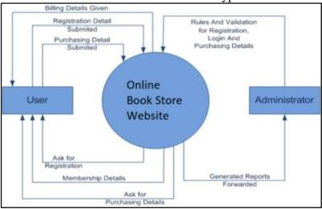

##### Figure 2.1 : System Architecture Diagram

Therefore, there is a need to further study e-books from adoption/usage to how to better manage a large volume of e-books via cloud-based bookstores, forming the basis of this study. By understanding the factors that influence users' continuous usage of cloud- based bookstores, organizations can better manage their e-book collections and provide users with the necessary resources to enhance their reading experiences. Overall, cloud computing has the potential to revolutionize the way we access and utilize computing resources, and with further research and development, it could become the standard model for computing in the future.

##### Continuous Use of Information Systems :

Oliver's Expectation Disconfirmation Theory (EDT) is commonly used to study consumers' repeat-purchase behavior in marketing. However, EDT has some limitations as it assumes that expectations will change based on experience, without an easy way to measure perceived performance. To overcome these limitations, Bhattacherjee developed the Expectation Confirmation Model (ECM) to predict individuals' continuous use of information systems. The ECM incorporates perceived usefulness to explain how an individual's perceived belief affects their repeated use of an IS. The model proposes that users record their original expectations before using an IS and then judge their own perceived usefulness after gaining usage experience. Users then evaluate their original expectations to establish their level of satisfaction with the use of an IS, which drives their decision to continue or discontinue using it. The ECM is a useful tool for studying user behavior and predicting their use of information systems over time.

The Expectation Confirmation Model (ECM) proposed by Bhattacherjee has been widely used to examine the continuous use of an information system. However, researchers have identified some limitations to the ECM in explaining users' ongoing

use of an IS. For instance, a study by Hong et al. (2011) found that perceived enjoyment, which is not accounted for in the ECM, is a significant predictor of users' continuous use of social networking sites. Similarly, a study by Venkatesh et al. (2012) revealed that users' habit is a stronger predictor of continuous use of an IS than expectation confirmation.

Moreover, the existing literature suggests that the ECM may not provide sufficient insights for practitioners to make specific improvements to an IS. Therefore, there is a need for further extensions to the ECM to gain a more comprehensive understanding of users' continuous use of an IS.

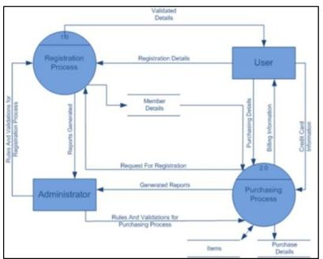

##### Figure 2.2 : UML Design

To address these limitations, researchers have proposed several extensions to the ECM. For instance, the Technology Acceptance Model (TAM) was integrated with the ECM to create the TAM-ECM model, which incorporates perceived ease of use and perceived usefulness as predictors of users' continuous use of an IS (Park & Chen, 2013). Another extension to the ECM is the inclusion of trust as a predictor of users' continuous use of an IS, as proposed by Wang and Emurian (2005).

In summary, while the ECM has been widely used to analyze the continuous use of an IS, it has some limitations, and extensions have been proposed to gain a more comprehensive understanding of users' behavior.

In order to enhance their task performance, individuals often choose a technology tool that best suits their task characteristics. To investigate the impact of technology on task performance, the task-technology fit theory (TTF) is widely used to explore the relationship between task-technology fit and users' performance. TTF refers to how well a technology tool can support individuals in completing their tasks. Individuals are more likely to adopt a technology tool if it closely matches the tasks to be performed. For instance, an accountant may use accounting software such as QuickBooks or Xero for bookkeeping tasks to improve performance.

Various studies have employed the TTF model to examine the performance impact in different contexts and extended it to provide a more comprehensive explanation of the relationship between technology, task, task-technology, and technology utilization. Utilization refers to an individual's behavior of using technology to complete tasks. However, simply utilizing a technology tool does not guarantee better performance. Goodhue and Thompson found that an individual's task performance depends more on TTF than utilization. For example, a salesperson using a customer relationship management (CRM) tool may not perform well if the tool does not provide the necessary features to support the sales process.

Moreover, TTF has been shown to have a significant impact on task performance in various fields, such as healthcare, education, and finance. In healthcare, TTF has been found to influence the use of electronic health records (EHRs) by physicians and nurses, affecting their efficiency and quality of care. In education, TTF has been linked to students' academic performance, where technology tools that match their learning styles can improve their engagement and understanding. In finance, TTF has been identified as a critical factor in the adoption and use of online trading platforms, where a good fit between the technology and traders' strategies can lead to better investment outcomes.

Task-technology fit is a concept that reflects the interaction between the complexity requirements of a task, user abilities, and the functions of information technology or information systems. There are different conceptualizations of a task, but the task- qua-task approach emphasizes the actual materials used in a task, while the task serving as a behavioral requirement approach focuses on the behavior requirements of a task. The task complexity can be integrated into these approaches to emphasize the task's characteristics presented to decision makers.

There are three distinct approaches to defining fit based on the structural contingency theory: fit as internal consistency, fit as interaction, and fit as congruency. However, out of the six fit perspectives proposed by the theory, the last three are not suitable for linking task-technology fit to effective performance in decision-making tasks.

A study showed that higher-level managers especially favor ample media for information processing and communication, implying that the right information technology can support a task best. For example, a cloud-based bookstore can be employed from any time and place, by any user, making it a suitable technology for mobile IS environments. However, it is important to understand the complexity of interwoven factors comprising the user, technology, and environment.

To evaluate technology usage and performance, it is recommended to include user- context characteristics in addition to task and technology characteristics. The task- technology fit can be deconstructed into ideal task-technology fit and individual use context-technology fit, as "task-individual fit" does not consider technology

characteristics. The TTF construct is important in forecasting technology utilization, but it is still a developing concept, and diverse forms of TTF-based models exist.

In a study on information system continuance, perceived technological characteristics were found to be insufficient in increasing continuance intention, highlighting the need to extend the TTF construct to information system continuance by integrating other concepts. Thus, a combination of TTF and ECM is proposed to explain cloud- based bookstore continuance comprehensively.

For example, in the case of a cloud-based bookstore, the ideal task-technology fit would involve a cloud-based system that provides end users with a reliable, customized, and dynamic computing environment, while individual use context- technology fit would consider factors like location, time criticality, functionality, etc. Additionally, the design of informational systems should include the individual use context to account for these limitations.

Overall, understanding the task-technology fit and its deconstruction into ideal task- technology fit and individual use context-technology fit is crucial in determining the effectiveness of information technology or information systems in supporting decision-making tasks. By considering various factors such as the user, technology, and environment, a comprehensive understanding of the TTF construct can be achieved, leading to improved technology utilization and performance.

Cloud computing has become an integral part of the modern-day digital infrastructure. With more and more businesses embracing the cloud, there are a number of cloud service providers that have emerged in the market. In this article, we will discuss some of the top cloud providers like AWS, Google Cloud, Azure, and others, their market shares, and recent trends.

Software as a Service (SaaS) is the highest level in cloud computing services, and it originated when the internet started gaining more prominence. At this level, organizations provide applications as a service to customers, and users can access the software applications via the internet without having to download or install them locally. Initially, SaaS emerged from the host functions of the Platform as a Service, and it has grown to offer numerous options to both businesses and individuals, including educational institutions. While SaaS services offer geographical flexibility, data confidentiality can be a concern since data is directly shared over the internet. As a result, Virtual Private Networks (VPNs) are frequently used to encrypt data sent over the internet, ensuring that user and SaaS data is kept secure and confidential.

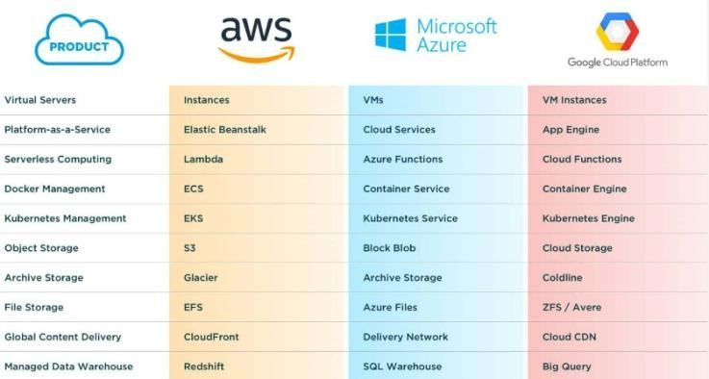

**Figure 2.3 : Comparing Different Cloud Platforms**

**AWS (Amazon Web Services)**

Amazon Web Services (AWS) is a cloud computing platform offered by Amazon.com. AWS offers a broad range of services including compute, storage, database, analytics, machine learning, and more. Some of the popular services offered by AWS include Amazon EC2, Amazon S3, Amazon RDS, Amazon Aurora, Amazon DynamoDB, Amazon Redshift, and Amazon EMR.

AWS is the market leader in the cloud computing space with a market share of over 30%. According to Synergy Research Group, AWS generated over $40 billion in revenue in 2020. AWS's dominance in the cloud computing market can be attributed to its wide range of services, global infrastructure, and strong customer support.

**Recent trends:**

AWS has been heavily investing in artificial intelligence (AI) and machine learning (ML) technologies, with the launch of services like Amazon SageMaker, Amazon Rekognition, and Amazon Polly.

AWS is also making strides in the edge computing space with the launch of AWS Outposts, a service that enables customers to run AWS infrastructure on-premises.

#### Google Cloud

Google Cloud is a cloud computing platform offered by Google. Google Cloud offers a range of services including compute, storage, database, analytics, machine learning, and more. Some of the popular services offered by Google Cloud include Google

Compute Engine, Google Cloud Storage, Google Cloud SQL, Google BigQuery, and Google Cloud AI Platform

Google Cloud is the third-largest cloud provider with a market share of around 9%. According to Synergy Research Group, Google Cloud generated around $6 billion in revenue in 2020. Google Cloud's strengths lie in its strong data analytics capabilities and its integration with Google's other services.

**Recent trends:**

Google Cloud has been investing heavily in the healthcare sector, with the launch of services like Healthcare API and Cloud Healthcare Data Processing.

Google Cloud is also focusing on sustainability, with the launch of Carbon-free Regions, a service that enables customers to run their workloads in regions powered by carbon-free energy sources.

#### Azure (Microsoft Azure)

Azure is a cloud computing platform offered by Microsoft. Azure offers a wide range of services including compute, storage, database, analytics, machine learning, and more. Some of the popular services offered by Azure include Azure Virtual Machines, Azure Blob Storage, Azure SQL Database, Azure Cosmos DB, and Azure Machine Learning.

Azure is the second-largest cloud provider with a market share of around 20%. According to Synergy Research Group, Azure generated around $20 billion in revenue in 2020. Azure's strengths lie in its strong enterprise offerings and its close integration with Microsoft's other services.

**Recent trends:**

Azure has been focusing on hybrid cloud solutions, with the launch of Azure Arc, a service that enables customers to manage their on-premises, multi-cloud, and edge deployments using Azure management tools.

Azure is also making strides in the quantum computing space, with the launch of Azure Quantum, a service that enables customers to experiment with quantum algorithms and technologies.

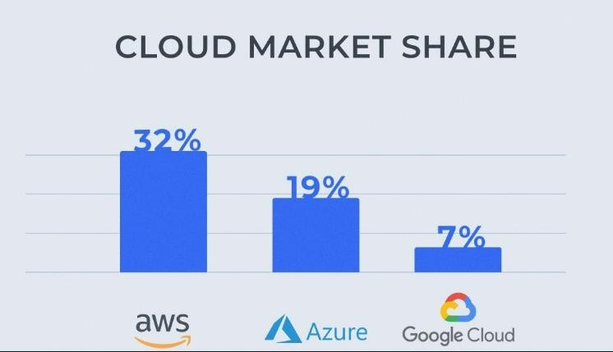

##### Figure 2.4 : Cloud Market Share

**Existing features provided by online bookstores typically include:**

Search functionality: Customers can search for books based on various criteria such as author, title, genre, or ISBN.

Recommendations: Online bookstores often suggest books to customers based on their previous purchases or browsing history.

Reviews and ratings: Customers can leave reviews and ratings for books they have purchased or read, which helps others to make informed decisions.

Preview or sample chapters: Many online bookstores allow customers to read a few pages of a book before purchasing it.

E-books and audiobooks: Many online bookstores offer e-books and audiobooks in addition to physical books.

Customer support: Online bookstores typically provide customer support through email, chat, or phone.

**Here are some more ideas for easy-to-add features for an online bookstore:**

Wishlists: Allow customers to create wishlists of books they want to buy in the future, making it easier to keep track of books they're interested in.

Related items: Show related books or items on the book detail page to help customers find other books they might be interested in.

User-generated content: Allow customers to contribute content such as book reviews,

ratings, or recommendations.

Gift cards: Allow customers to purchase gift cards, which they can give to friends or family members to buy books from the online bookstore.

Discounts and promotions: Offer special discounts and promotions to customers who subscribe to the bookstore's email newsletter.

Book bundles: Create book bundles or packages that offer multiple books for a discounted price.

Local bookstores: Highlight local bookstores in the area, so customers can support their local bookstores while browsing online.

Reading challenges: Introduce reading challenges, where customers can set goals for how many books they want to read and track their progress.

Author events: Promote author events such as book signings, Q&A sessions, or live talks, which customers can attend online.

Social media integration: Allow customers to share their favorite books or reviews on social media platforms like Twitter or Facebook.

Personalized recommendations: Develop a recommendation engine that uses machine learning to suggest books to customers based on their reading history and preferences.

Book clubs: Introduce a feature that allows customers to create book clubs and discuss books with other readers.

Bookmarks and highlights: Create a feature that allows customers to bookmark pages and highlight sections of a book they are reading.

Virtual bookshelf: Develop a feature that allows customers to create a virtual bookshelf to organize their purchases and track their reading progress.

Collaboration with authors: Develop a feature that allows authors to interact with readers through Q&A sessions or book signings.

These are just a few ideas, and there are many other features that could be introduced to make an online bookstore more engaging and useful for customers.

These are just a few more ideas to get you started. Depending on the specific online bookstore you are developing, you may need to tailor these ideas or come up with different features that are relevant to your customers.

**Table 1 : Existing Features and the features that can be implemented**

|  |  |
| --- | --- |
| **Existing Features** | **Features that can be implemented** |
| Search functionality | Social media integration |
| Recommendations | Personalized recommendations |
| E-books and  audiobooks | Virtual bookshelf |
| Advanced search filters (e.g. by publication date, format, or Wishlist  language) | Wishlist |
| Recently viewed  items Related items | Related items |
| New releases lists | Gift cards |
| Categories or genres | Discounts and promotions |
| Top-rated books | Book bundles |
| Personal user profile | Local bookstores |

# Chapter 3 : System Design

### DFD Diagram

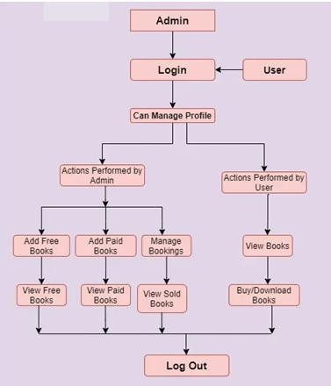

**Figure 3.1 : DFD Diagram**

### Use Case Diagram

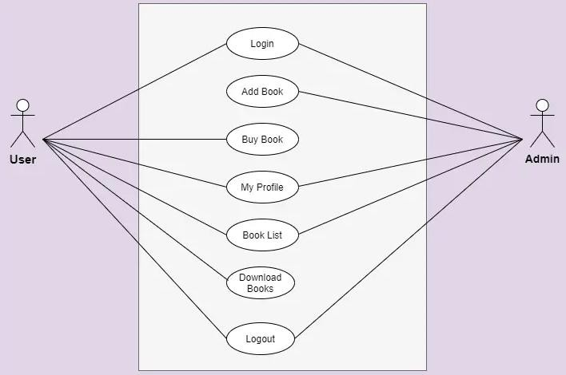

##### Figure 3.2 : Use Case Diagram

The figure above shows the use case diagram of Online Cloud Enabled Bookstore System. There are some functions provided by the system.

* Login

Login function is needed to identify whether the user is client or admin. Different roles can perform different tasks.

* Add Book

This feature can only be accessible by the admin because they have the rights to add books in the system.

* Buy Book

This feature is only given to user side because only they can buy the products from the online system.

* My Profile

Both user and admin have their profile on the system to add books or buy from it.

* Book List

This feature is provided to both user and admin. Admin can see the book lists which are added on the system and user can see the list of books which are purchased and downloaded by them.

* Download Books

Only users has given this permission so they can download the required books of their need.

* Logout

Both have logout features so they can logout from the system when the work is done.

### User Interface Design

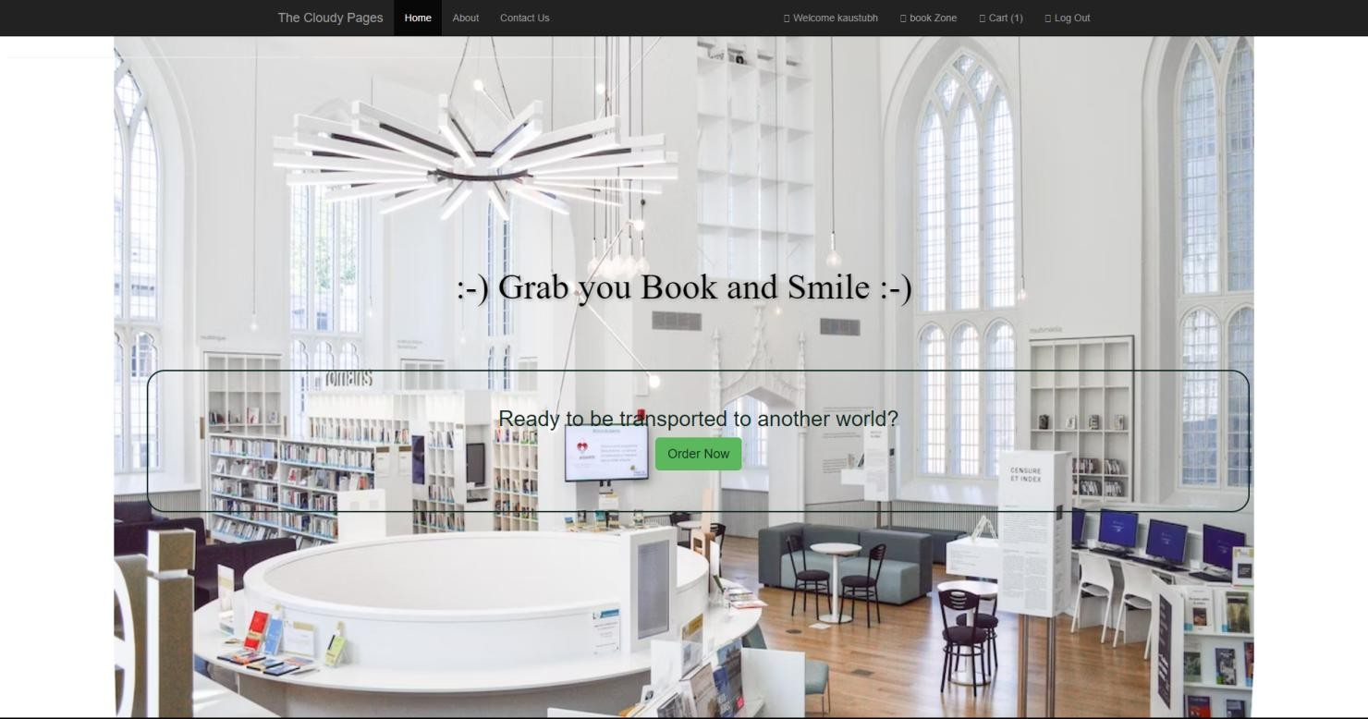

##### Figure 3.3 : Home Page

This is the home page of the system. The customers can click on the place order button to view the books. The staff and chef can click on the admin login button to login to the system.



##### Figure 3.4 : Welcome Page1

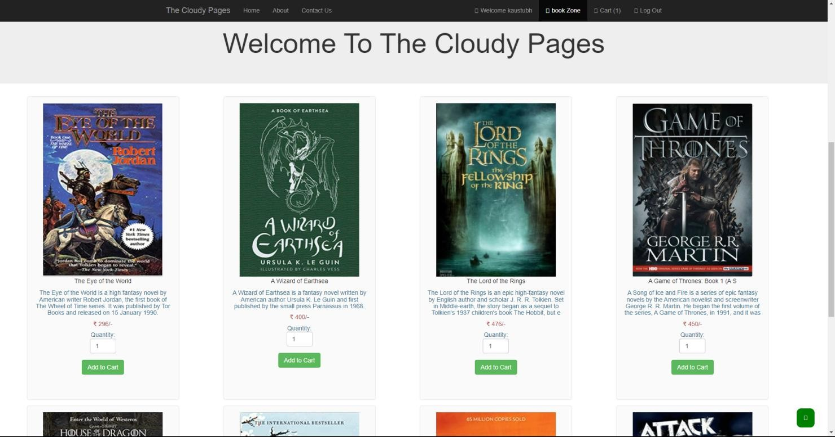

**Figure 3.5 : Welcome Page2**

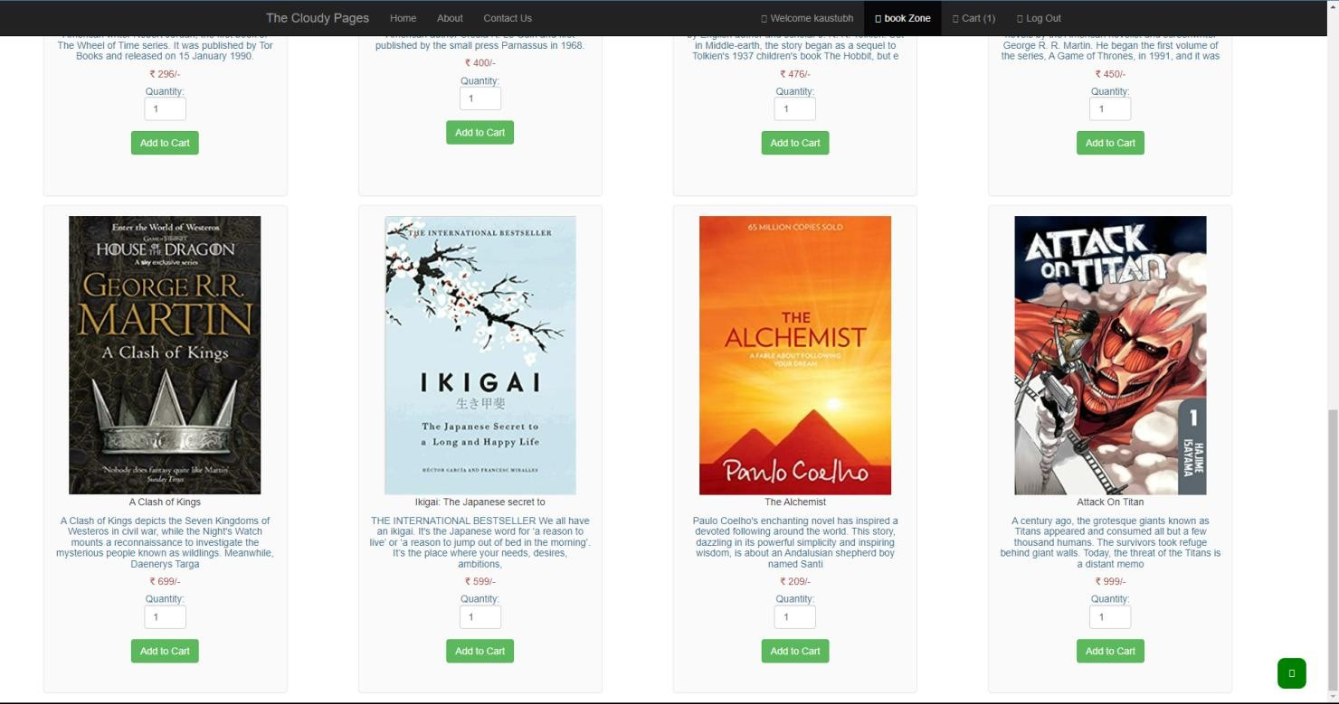

##### Figure 3.6 : Welcome Page3

After the customers click the place order button, this page will be displayed to the customers. The customers can choose the category to view the books. If the customers wish to order the books, they can click on the order button.

Let’s say we want to order any of the two things from the list, the items are added to the cart. Here is the picture of our cart.

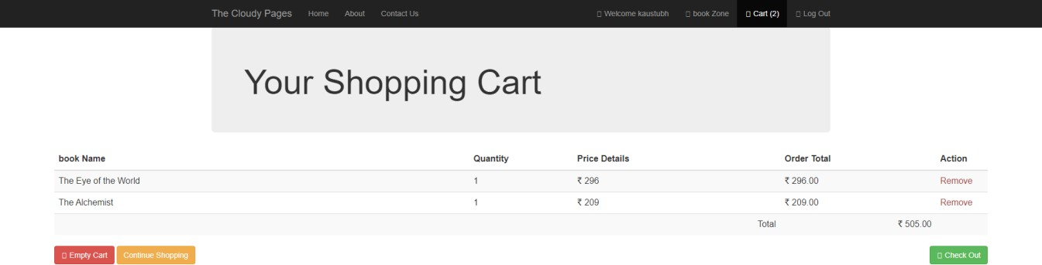

##### Figure 3.7 : Shopping cart

Here if the user checks out, our system will provide the user with two choices:-

* + 1. Pay Online
    2. Cash On Delivery

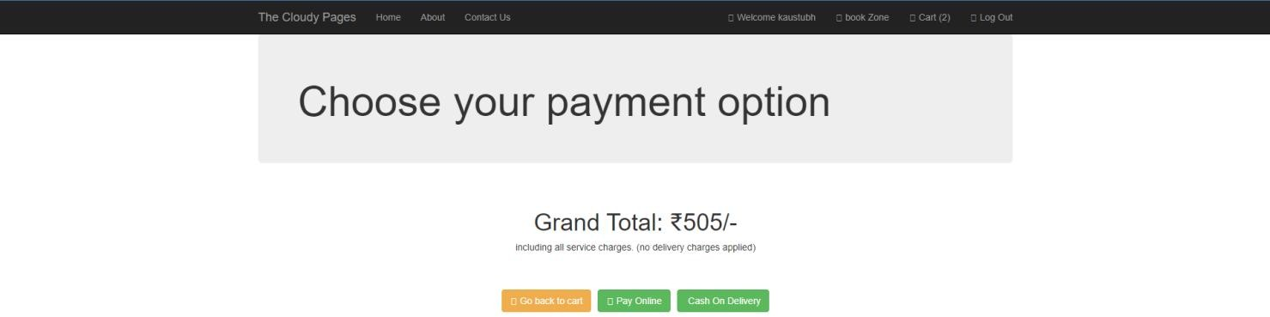

##### Figure 3.8 : Payment Options

If the user opts for pay online, we will ask the user to give his credit card details for further transactions, here we ask the user for their credit card number, expiry month and year, cvv and Name on the card.

We also provide a option for saving card for fast payment.

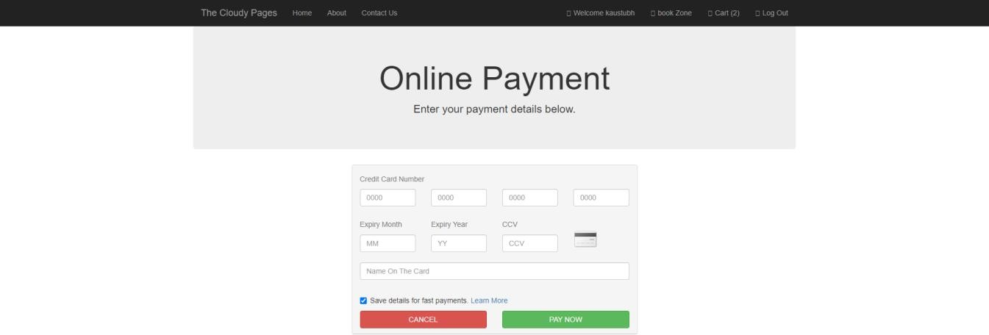

##### Figure 3.9 : Payment Screen.

And after this the user’s order will be confirmed and will be processed.

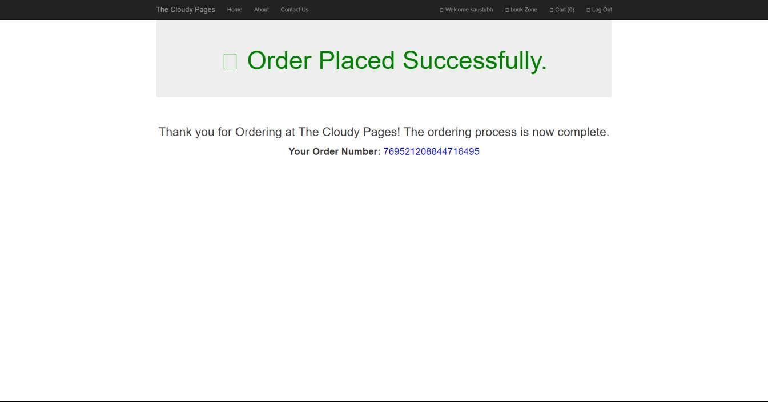

### Login Area

##### Figure 3.10 : Order Confirmation Screen

Here we have given the option to select you login as Customer or as a Manager.

The customer can only order the books while the manager can manage all the stuffs happening like managing the orders, adding and deleting the books etc.

### Customer Login

Here the customer can log himself in the bookstore, and for the ones who are ordering for the first time we have provided a create new account option to log them into our database.

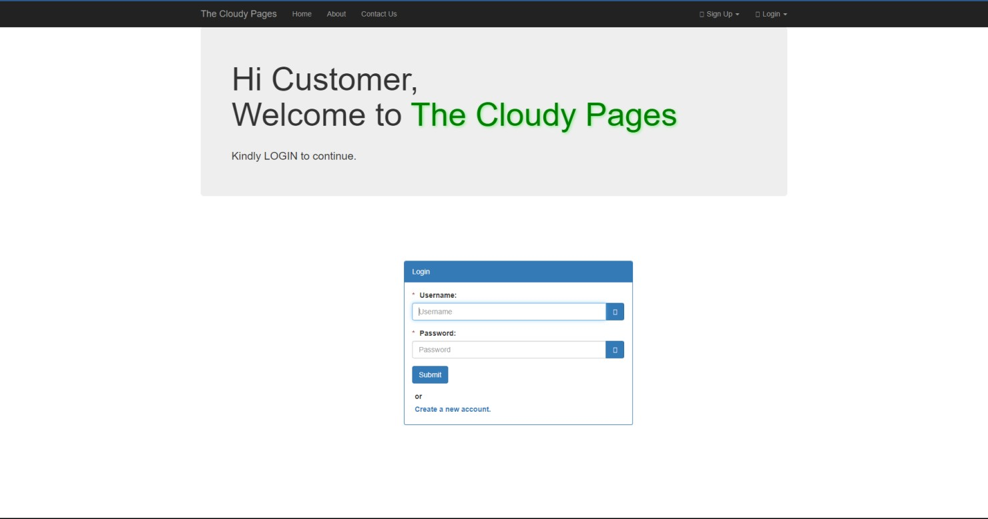

##### Figure 3.11 : Customer Login

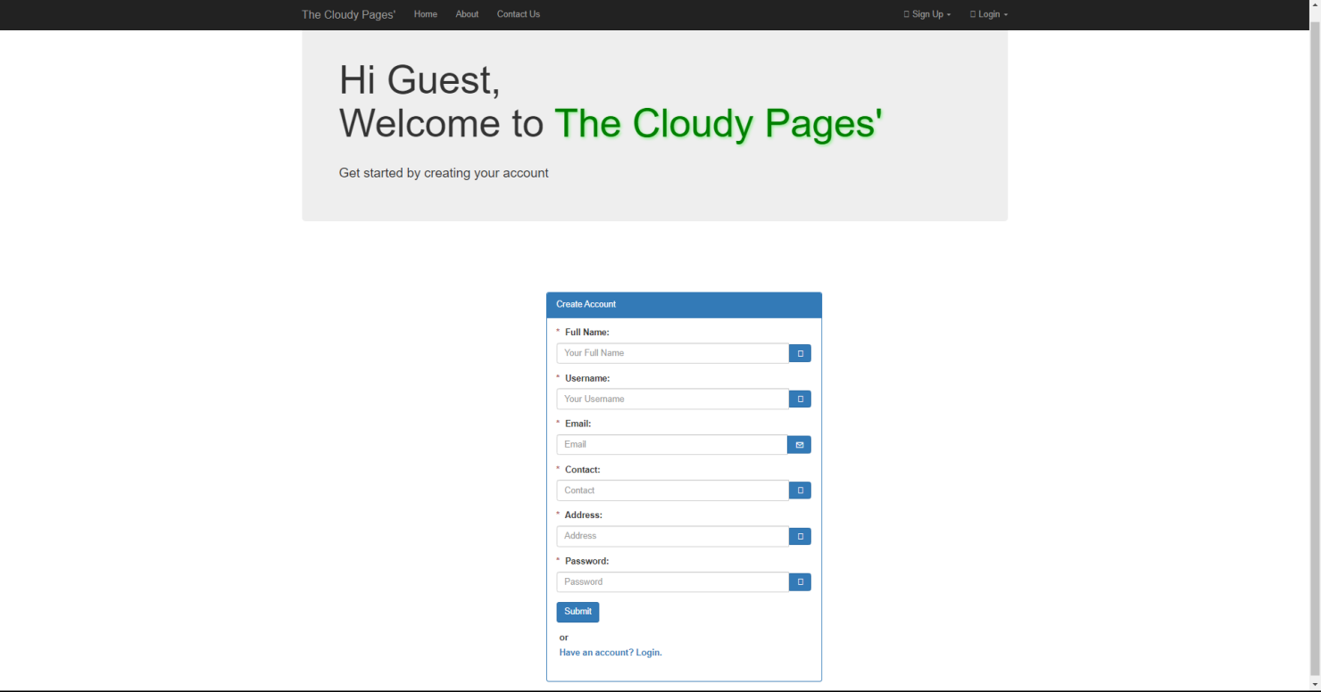

**Figure 3.12 : Customer Sign in**

### Manager Login

Here the manager will access the bookstore and will manage the stuffs happening behind.

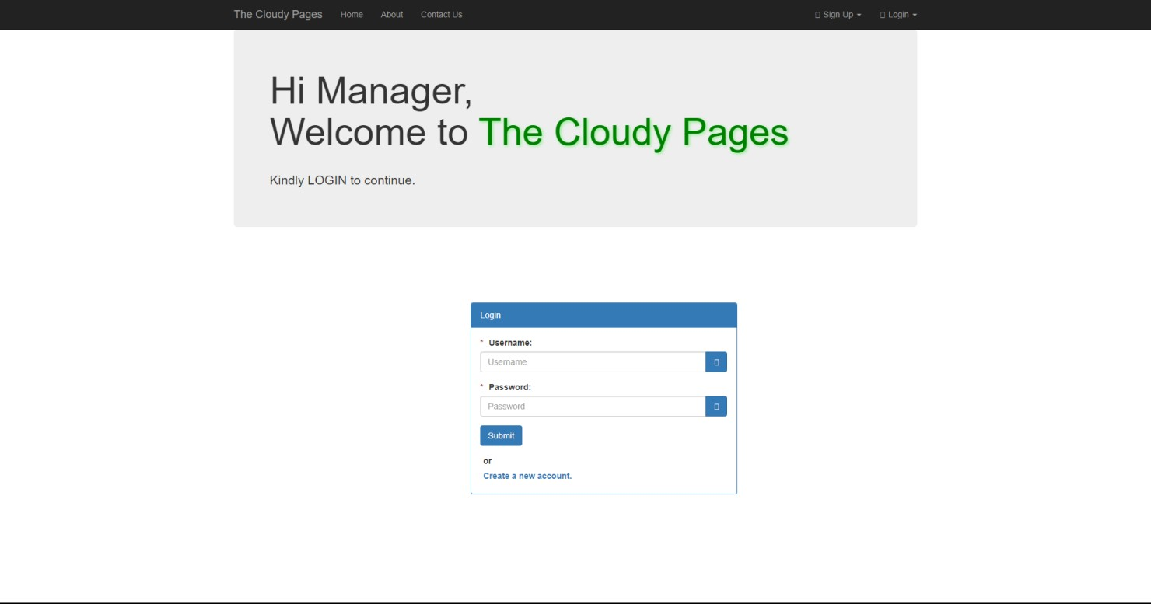

##### Figure 3.13 : Manager Login

We also allow the new manager to take over, hence we provided a section where a new manager can create his login Id.

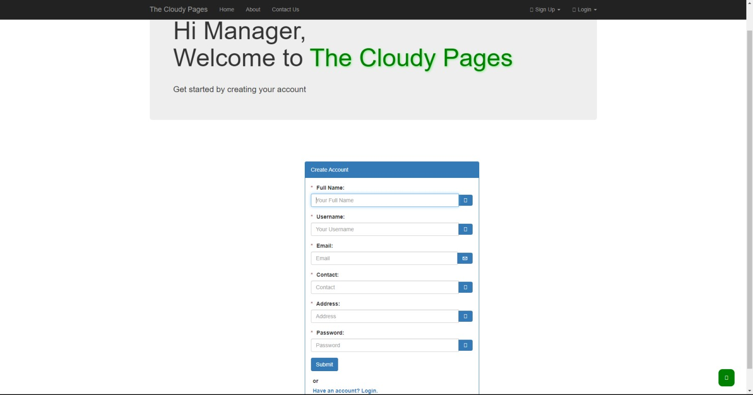

##### Figure 3.14 : Manager Sign Up

When a manager logs in the system the first thing he sees is the My Bookstore page.

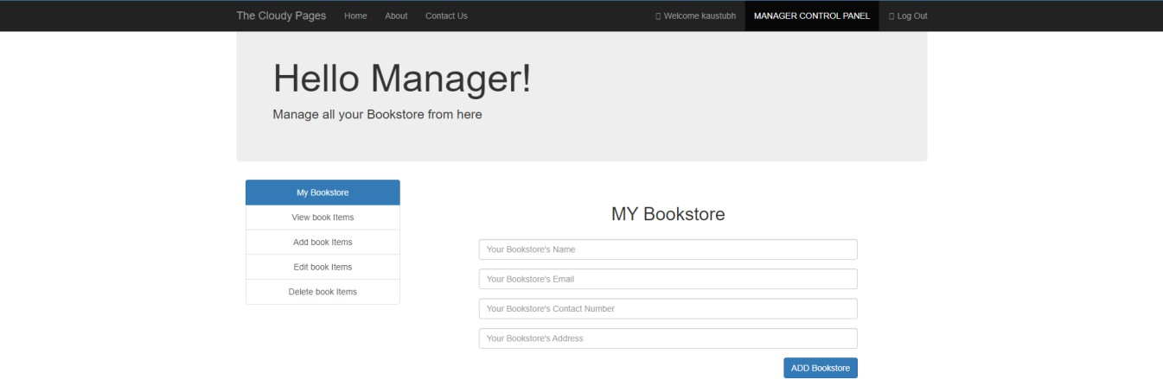

##### Figure 3.15 : My Bookstore

Here the manager can change the Bookstore name, email, contact number and address.

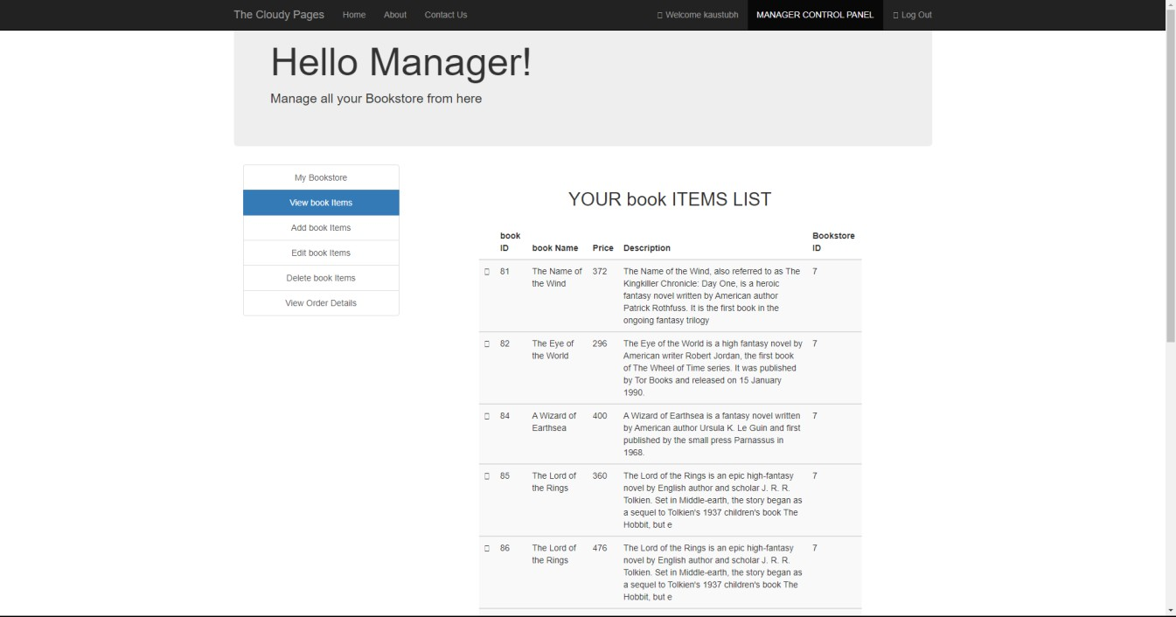

##### Figure 3.16 : View Book Items

Here all the book items added by the manager will show up.

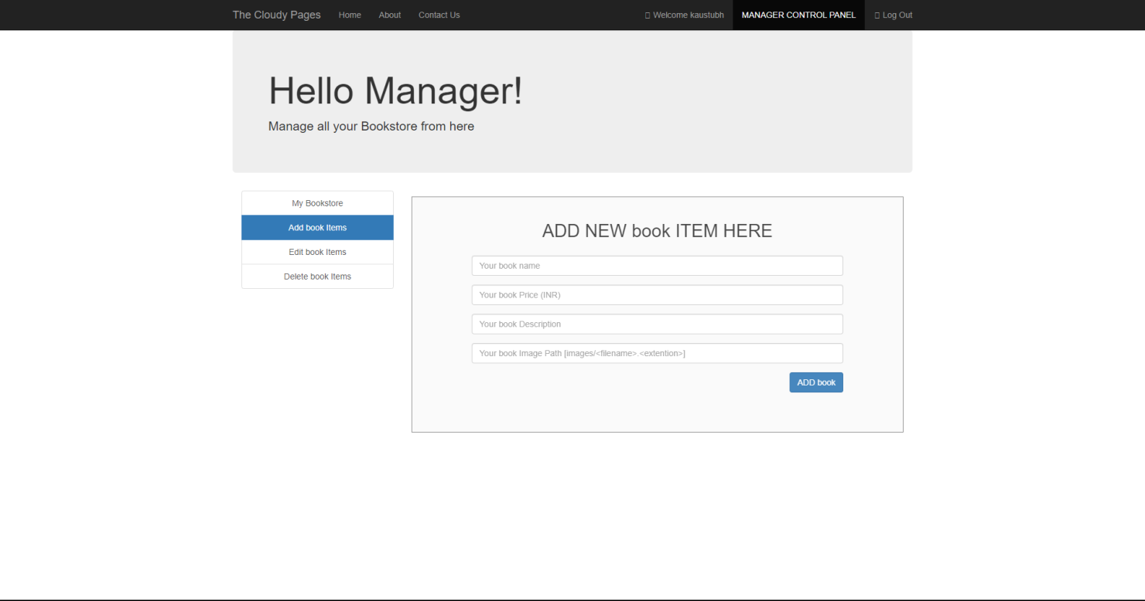

**Figure 3.17 : Add Book Items**

Here the manager can add more book items to the book list.

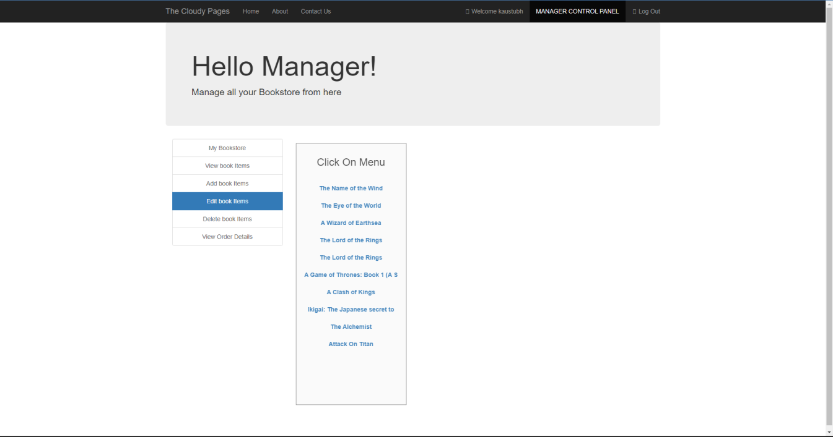

##### Figure 3.18 : Edit book items

Here the manager can edit the book items in the book list list.

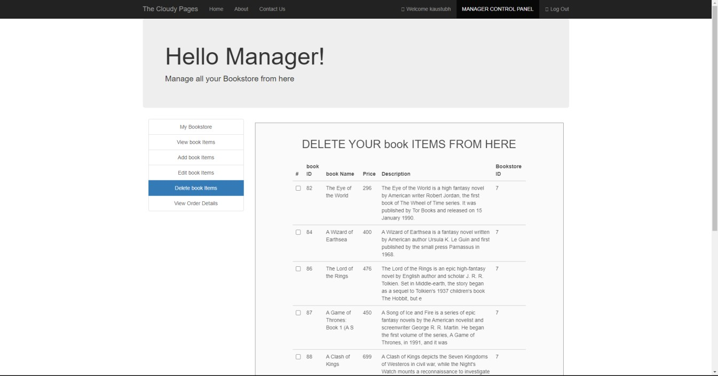

##### Figure 3.19 : Delete book Items

Here the manager can delete the book items from the main book list.

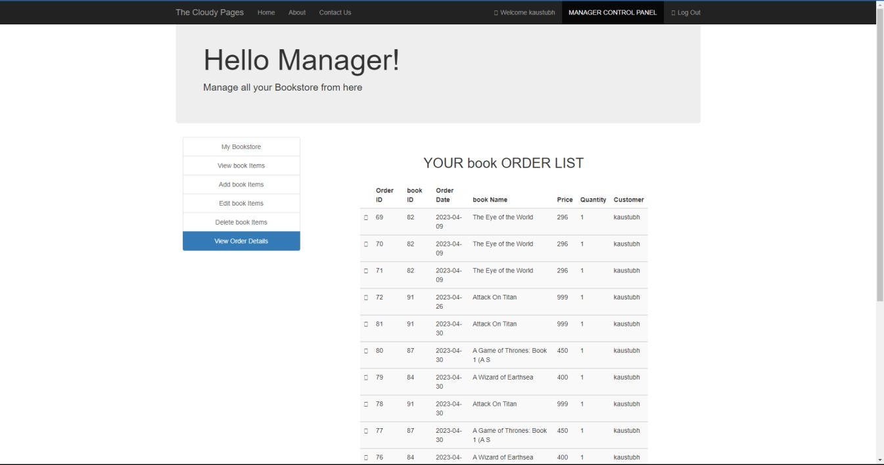

##### Figure 3.20 : Order History

Here the manager can see the full history of the items ordered.

We have stored all these images used in this project in a folder names Images

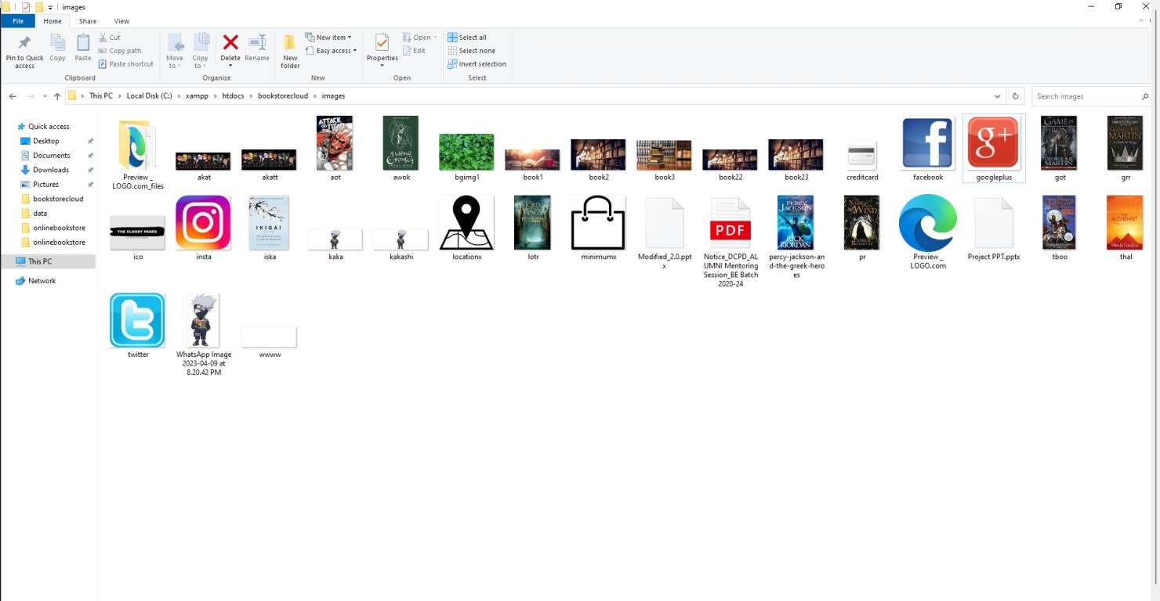

##### Figure 3.21 : Images Folder

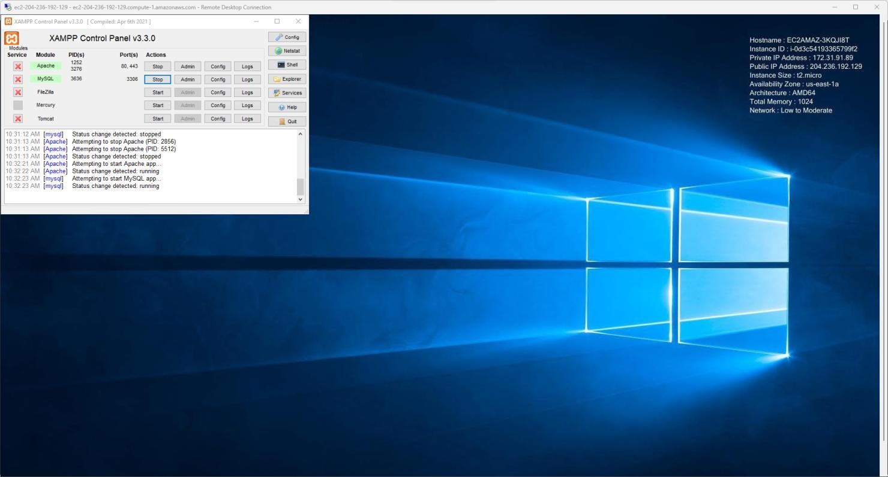

**Figure 3.22 : Server on Amazon AWS**

This shows the server running on the Amazon AWS EC2 Instance (Cloud hosting)

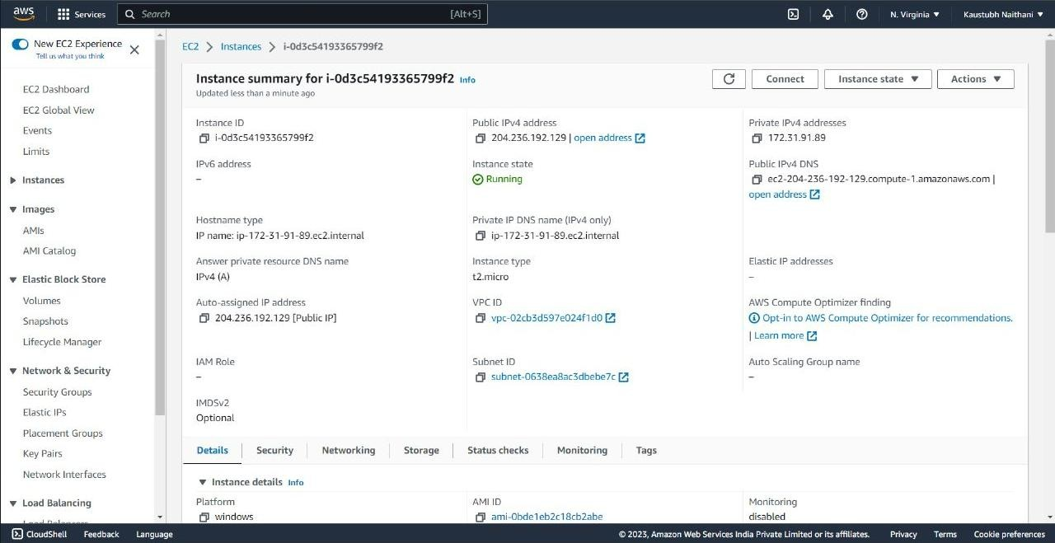

##### Figure 3.23 : EC2 instance details

Here on the console we see all the details of the instance, like the public and private ip address, dns , and other options to view the networking , security , storage details

, and also tools for monitoring the server.

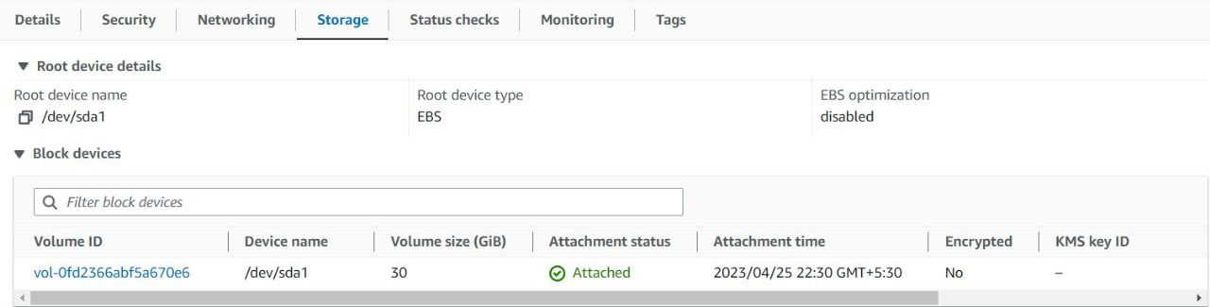

##### Figure 3.24 : The storage details

Amazon EC2 provides various storage options including Elastic Block Store (EBS) for persistent block-level storage, Instance Store for temporary instance storage, and Amazon Elastic File System (EFS) for scalable network file storage.

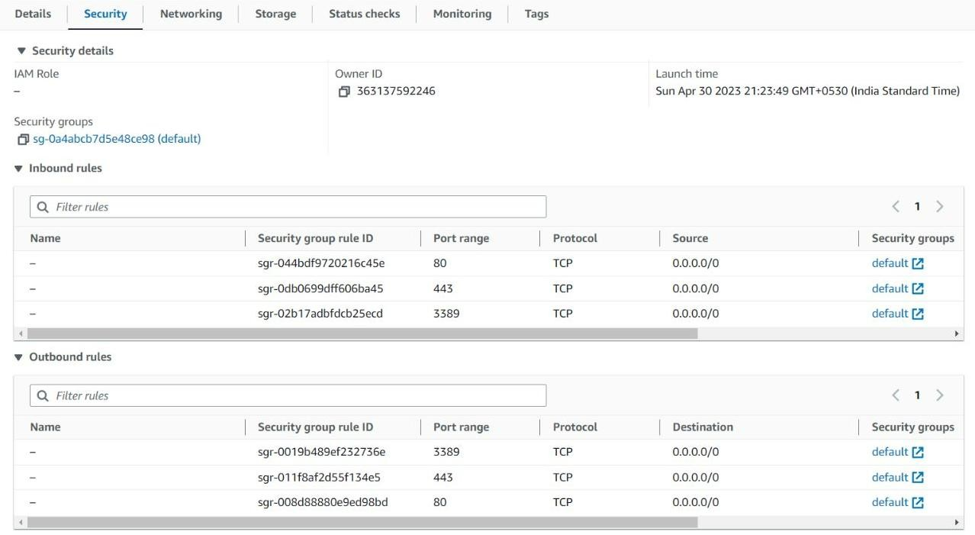

##### Figure 3.25 : Security Details

Amazon EC2 offers various security measures such as Virtual Private Cloud (VPC), Security Groups, Network ACLs, Identity and Access Management (IAM), and encryption options to secure instances and data at rest and in transit.

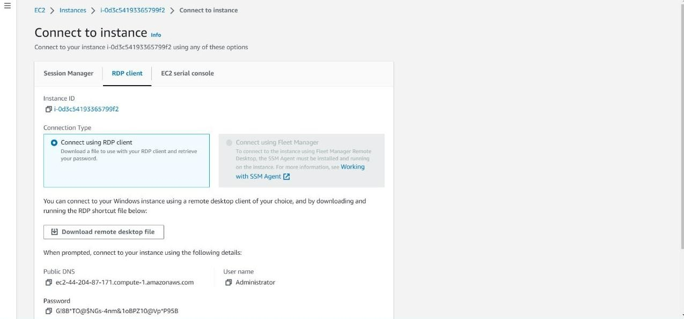

##### Figure 3.26 : Connecting to Instance using RDP

To connect to an Amazon EC2 instance using Remote Desktop Protocol (RDP), users need to create a Windows instance and configure its security group and firewall settings to allow RDP traffic. Then, they can use a Remote Desktop client to connect to the instance using its public IP address.

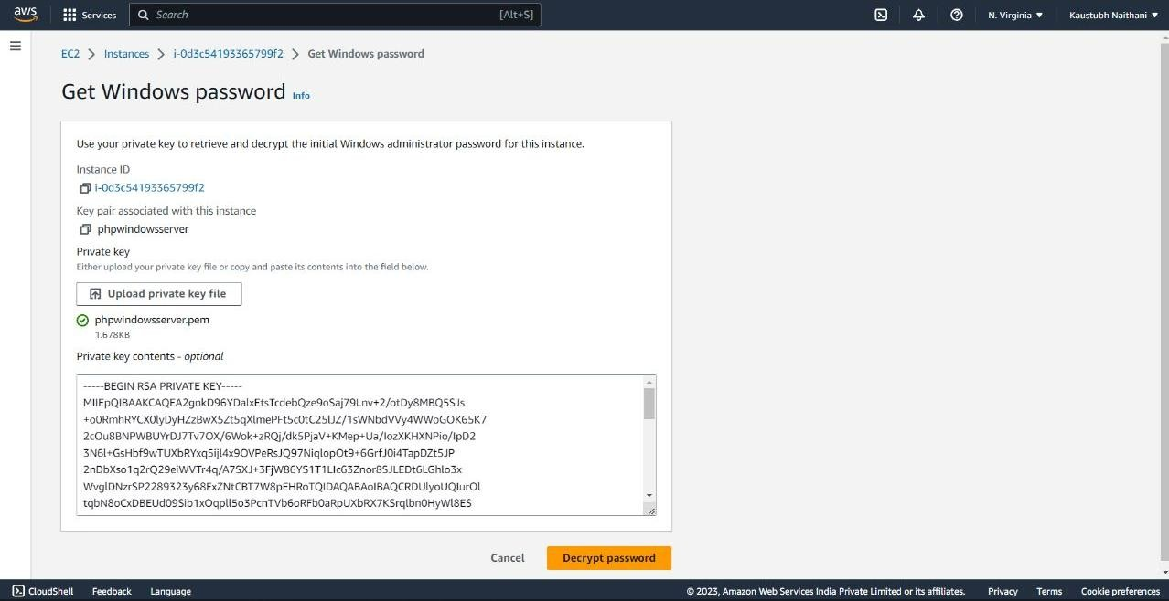

##### Figure 3.27 : Password for the windows server

When creating a Windows instance on Amazon EC2, users can generate a random password or provide their own. The password is encrypted with an RSA key pair, and users can retrieve it using the EC2 console or the AWS CLI.

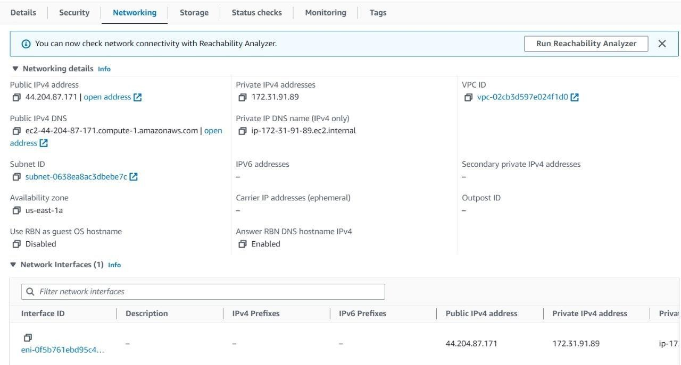

##### Figure 3.28 : Networking Information of the instance

Amazon EC2 instances can be launched in a Virtual Private Cloud (VPC), providing users with control over the network environment. Users can configure subnets, route tables, and security groups, and connect their VPC to other networks using VPN, Direct Connect, or AWS Transit Gateway.

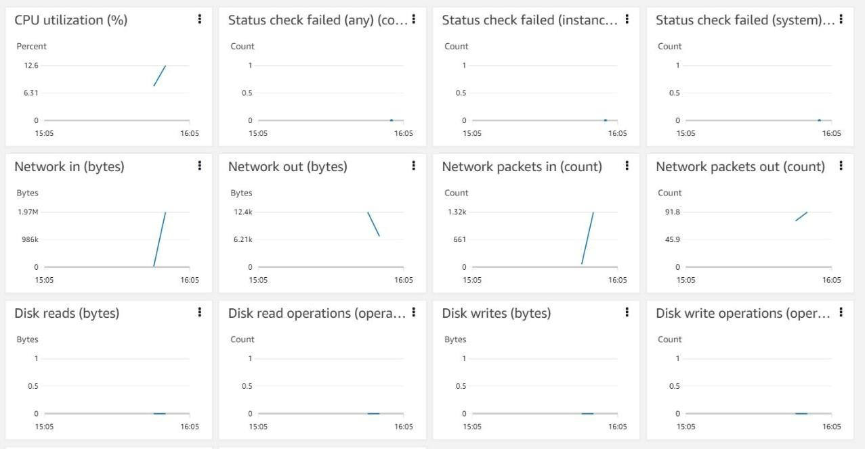

##### Figure 3.29 : Server Statistics of the instance

Amazon EC2 provides detailed server statistics such as CPU utilization, network traffic, disk I/O, and instance status via CloudWatch metrics. Users can also monitor logs and events using CloudWatch Logs and CloudTrail. Third-party monitoring tools like Datadog and New Relic are also available.

* 1. **Database**

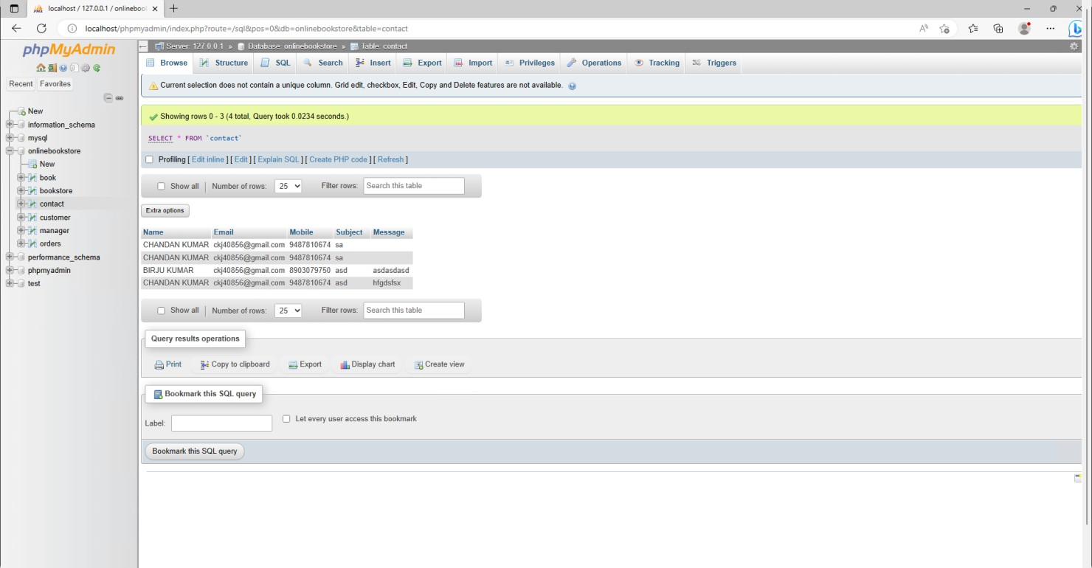

##### Figure 3.30: Database of customer detail

This is the table shows that have the contact of our clients and their details. It gets updated as a new client gets attached to our service and the table gets append and data is circulated among the whole database.

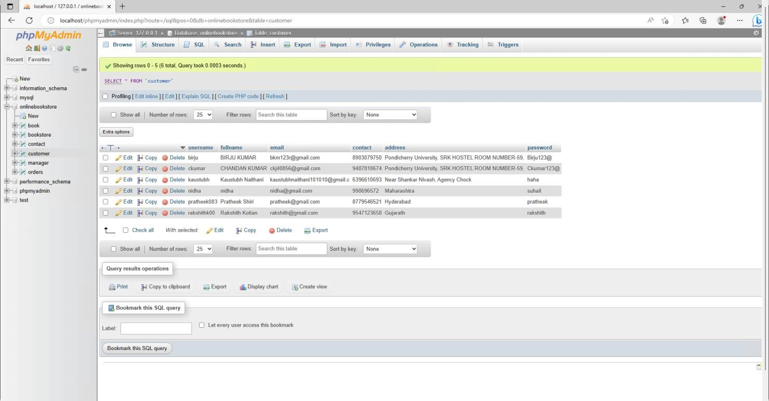

##### Figure 3.31 : Table of customer login credentials

This Data table here describes the Customer login details, password and their personal information.

The database gets appended by itself as the new customer sign up on the login page of our website and credentials are saved over here and can be used by the user to login to website and order gets linked by their credentials.

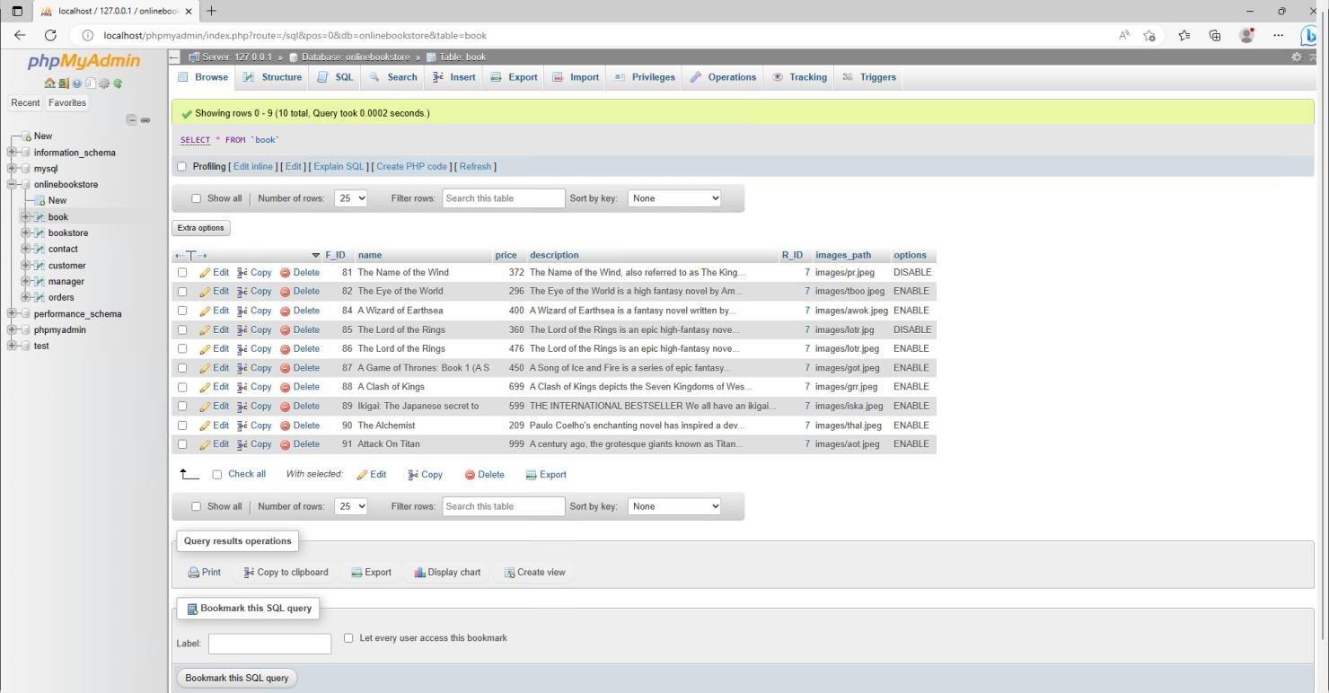

##### Figure 3.32 : List of all books in database

This database table hereby describes the list of all the books added by the managers individually. This also has description and the book price and the availability of the books can be managed personally by the manager.

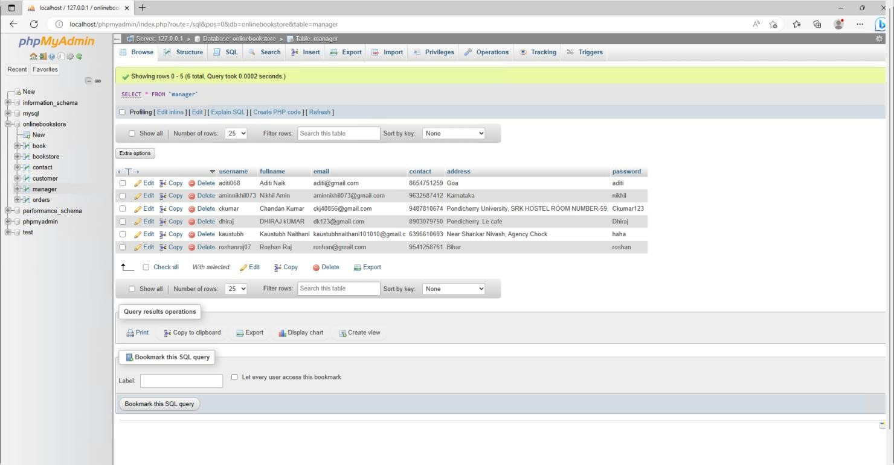

##### Figure 3.33 : Table of manager login credentials

This contains the Manager details and their login credentials also has some of their personal information. This is Managed by the Admin can be appended and used for login for the manager info.

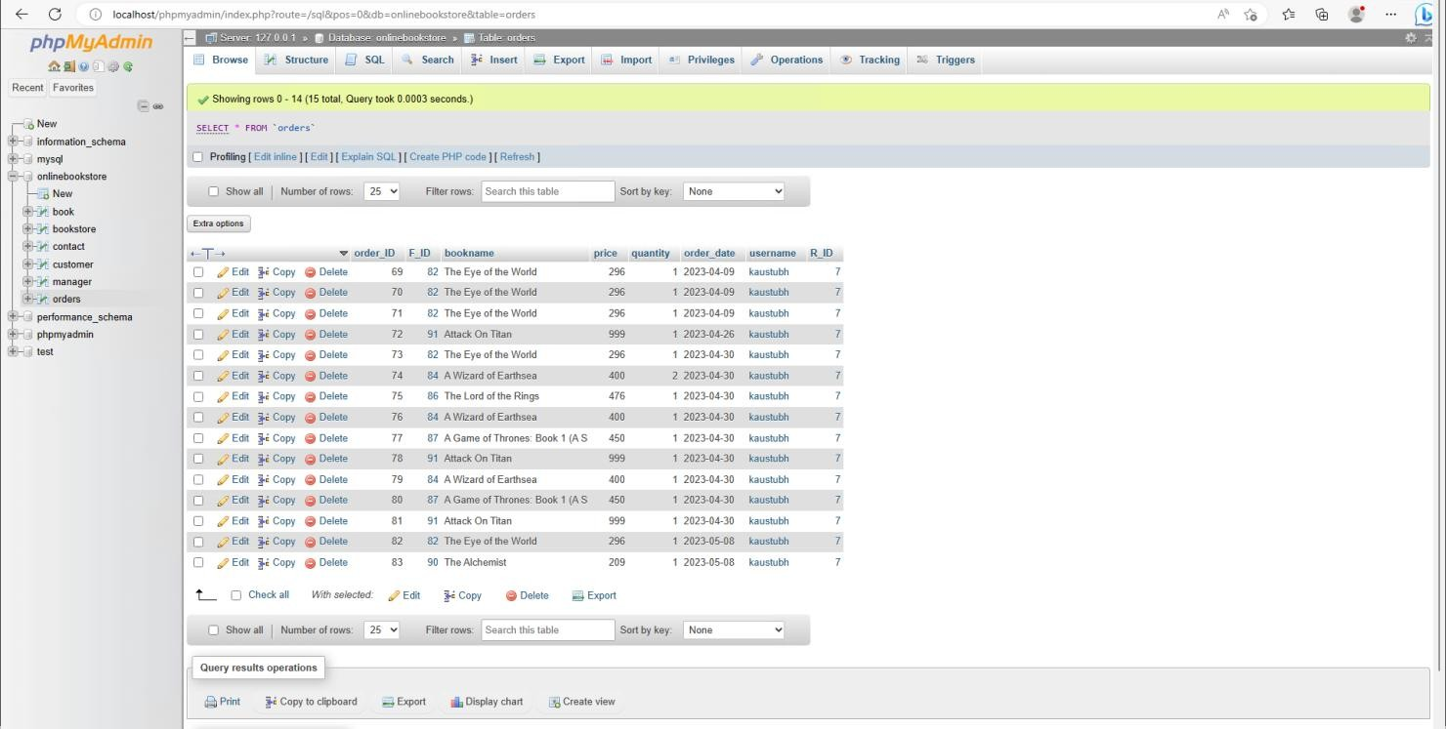

##### Figure 3.34 : Database of books ordered

This hereby is the auto generated table as soon as the order is placed by the user and gets confirmed by the manager. This table contains the bill details of the orders and personal information of the customer.

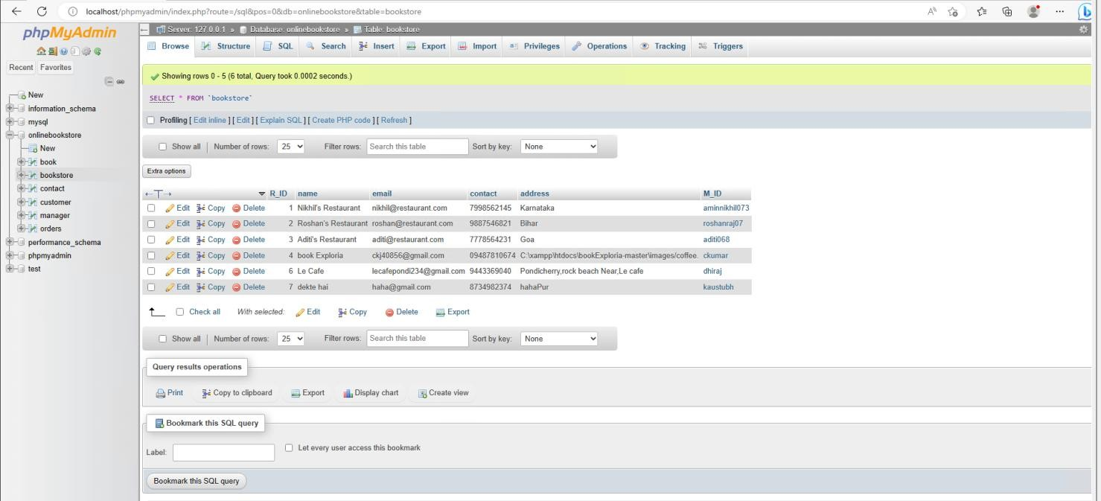

##### Figure 3.35 : Table of individual user bookstore

This Database table describes the Book’s Author Details their location ,number and their personal information and it is managed by the Admin can be appended . This can be edited from the database server.

## Chapter 4 Methodology

### Methodology Used

##### Requirement gathering:

This phase of the methodology involves gathering the requirements for the cloud-enabled bookstore system. Requirements gathering can be done through a variety of methods, such as user interviews, surveys, and studying existing systems in the market. The requirements gathered will include the features and functionality that the system must have to meet the needs of the customers. The system should allow customers to browse and purchase books online, and should include features such as real-time inventory management, personalized recommendations based on customer preferences, and easy payment options.

##### System design:

The system design phase involves creating a plan for how the system will be built. This includes designing the database schema, user interface, and cloud infrastructure. The database schema will define the structure and relationships between the data elements that will be stored in the database. The user interface will determine how the system will look and feel to the user, including the layout, color scheme, and user flow. The cloud infrastructure will include the services and resources needed to run the application in the cloud, such as virtual machines, storage, and networking.

##### Development:

In this phase, the system will be developed using appropriate technologies and programming languages. The database will be developed using SQL or NoSQL database technologies such as MySQL or MongoDB. The user interface will be developed using front-end web technologies such as HTML, CSS, and JavaScript, and web frameworks such as React, Angular, or Vue. The cloud infrastructure will be developed using cloud services such as Amazon Web Services (AWS) or Microsoft Azure.

##### Testing:

Once the development is complete, the system will be tested to ensure that it meets the requirements and is free from any bugs or errors. Testing will include unit testing, integration testing, and system testing. Unit testing involves testing individual components of the system, while integration testing tests how these components work together. System testing will test the system as a whole, including its performance and usability.

##### Deployment:

Once testing is complete, the system will be deployed on a cloud platform such as Amazon Web Services or Microsoft Azure. The cloud infrastructure will be configured, the database will be set up, and the application code will be deployed to the cloud environment.

##### Maintenance:

After deployment, the system will be maintained by performing routine updates, security checks, and backups. This will ensure that the system continues to function properly and remains secure. Maintenance may also include adding new features or making changes to existing ones, based on feedback from users or changes in the market.

This methodology provides a structured approach for developing a cloud-enabled bookstore system, from gathering requirements to deploying and maintaining the system. It emphasizes the importance of user-centered design, testing, and ongoing maintenance to ensure that the system meets the needs of customers and is secure and reliable.

### Tools

* PHP, HTML, CSS

These advances are utilized to fabricate the framework. PHP and HTML are utilized to construct the connection point of the framework and fabricate the usefulness of the framework. CSS is utilized to characterize styles of the framework.

* XAMMP

XAMPP is a free and open-source cross-platform web server solution stack package. This software is used to connect to Apache and MySQL.

* phpMyAdmin

phpMyAdmin is an open source and free administration tool for MySQL. This tool is used to insert the database.

* Visual Paradigm Community Edition Visual Paradigm Community Edition is a UML CASE Tool. This software is used to draw the use case diagram and activity diagram.
* VS Code

VS Code is a free and open-source text and source code editor. This software is used to code the system.

### Requirement

* XAMMP ControlPanelVersion3.2.3
* phpMyAdminVersion4.8.5
* Laptop OperatingSystem:Windows10

Processor: [Intel(R)Core(TM)i5-5200UCPU@2.20GHz](mailto:Intel(R)Core(TM)i5-5200UCPU@2.20GHz) 2.19GHz

### Implementation and Testing

The execution of the framework will be begun after the finish of the framework plan. The design of the information base will first and foremost form during improvement stage. Then, at that point, the server side and client side likewise worked to permit the correspondence among clients and staff. During the testing stage, scarcely any experiments are completed to test the framework. This is to ensure the framework is dependability.

Unit Testing1: Login

Test Objective: To ensure the user able to login with valid name and password.

##### Table 2: Login

|  |  |  |
| --- | --- | --- |
| Input | Expected output | Actual output |
| Login by entering correct name and  password. | The system let the user login. | The user login successfully. |
| Login by entering wrong password. | The system does not allow the user to  login. | The user can’t login to the system. |
| Login by does not enter any value. | The system does not allow the user to  login. | The user can’t login to the system. |

Unit Testing2: Add new book

Test Objective : To ensure the staff able to add new books into the system.

##### Table 3: Adding New Books

|  |  |  |
| --- | --- | --- |
| Input | Expected output | Actual output |
| Enter all the information of the books | The books information is stored into the  database. | The book information is stored into the database and the user can view the book in the list. |
| Enter few information of books | The books information will not be stored in the  database. | The system does not allow the user to add new books. |
| Click Save button without entering any information | The book information will not store into the  database. | The system does not allow the user to add new book. |

Unit Testing3: Add new category

Test Objective: To ensure the staff able to add new category into the system.

##### Table 4: Adding New Category

|  |  |  |
| --- | --- | --- |
| Input | Expected output | Actual output |
| Enter the information of the category | The category information is stored into the database. | The category information is stored into the database and the user can view the  category in the list. |

|  |  |  |
| --- | --- | --- |
| Click Save button without entering any information | The category information is not stored into the  database. | The system does not allow the user to add new category. |

Unit Testing4 : Order book

Test Objective: To ensure the customer able to order the Book.

**Table 5: Ordering Book**

|  |  |  |
| --- | --- | --- |
| Input | Expected output | Actual output |
| Enter the information of the quantity, table name and tick the checkbox. | The order is processed  successfully. | The customer is allowed to make the  order. |
| Enter the table  name information only. | The order does not process successfully. | The customer is not  allowed to make the order. |
| Enter the information  without entering table name. | The order does not process successfully. | The customer is not  allowed to make the order. |
| Click Order button without entering any  information | The order does not process successfully. | The customer is not allowed to make the  order. |

## Chapter 5 Conclusion

In conclusion, a cloud-enabled bookstore system is a modern solution to streamline bookstore operations, enhance the customer experience, and increase reach and visibility. The system aims to provide a user-friendly platform for customers to browse and purchase books online, automate inventory management, and improve communication between different departments. By leveraging cloud infrastructure, the system can reduce costs associated with maintaining a physical storefront while enhancing security and reliability. Additionally, the system can collect and analyze customer data to gain insights into customer behavior and preferences, enabling data-driven decision making. The methodology for developing such a system involves requirements gathering, system design, development, testing, deployment, and maintenance. Overall, a cloud-enabled bookstore system is a valuable investment for bookstores looking to stay competitive in today's digital age. In conclusion, the Cloud Enabled Bookstore System has revolutionized the way bookstores operate by allowing them to take advantage of the scalability, flexibility, and cost-effectiveness of cloud computing. This project report explored the various existing cloud-enabled bookstore systems and their features, highlighting the benefits of using such systems.

Some of the existing systems discussed in this report include Amazon Kindle, Google Books, and Apple iBooks. These systems have provided users with the convenience of accessing a vast library of books on any device connected to the internet. Additionally, they have offered a range of features such as annotations, highlighting, and personalized recommendations based on user preferences.

Our project, Cloudy Pages, is a new addition to this list of cloud-enabled bookstore systems. Our system is a web-based platform that provides users with an easy and convenient way to browse and purchase books online. Our website is hosted on Amazon AWS EC2, which provides us with the benefits of scalability, flexibility, and cost-effectiveness.

One of the key features of Cloudy Pages is the ability to browse books by category or author. This makes it easy for users to find books that interest them and purchase them with just a few clicks. Additionally, our system provides users with personalized recommendations based on their browsing history and purchase history.

Another notable feature of Cloudy Pages is the ability to read books online. Users can access their purchased books from any device connected to the internet,

making it convenient to read on the go. Our system also supports annotations, highlighting, and bookmarking, making it easy for users to keep track of important information while reading.

Our project has demonstrated the benefits of using cloud computing for the development of a bookstore system. By leveraging cloud technologies, we have been able to create a scalable, flexible, and cost-effective system that provides users with a convenient way to browse and purchase books online.

Hence , the Cloud Enabled Bookstore System is an innovative solution for bookstores looking to modernize their operations. Our project, Cloudy Pages, is an example of how such a system can be implemented using technologies such as PHP, MySQL, HTML, CSS, and jQuery and hosted on a cloud platform such as Amazon AWS EC2. With the increasing demand for online book purchasing and reading, cloud-enabled bookstore systems like Cloudy Pages are sure to play a significant role in the future of the publishing industry.

### Future Scope

The future scope of the Cloudy Pages project is quite broad, and there are several potential enhancements and additional features that could be added to the platform. Some of the key areas of potential expansion are discussed below:

Mobile Application: The first area of future scope for Cloudy Pages is the development of a mobile application. A mobile app would allow users to browse and purchase books on their smartphones and tablets, making it even more convenient to use the platform. Additionally, the app could include features like push notifications for new releases and exclusive discounts.

Audiobooks: Another area of potential expansion for Cloudy Pages is the addition of audiobooks. By adding audiobooks to the platform, users would have the option to listen to books while on the go, making it easier to fit reading into their busy schedules. This feature could be monetized through a subscription-based model, where users pay a monthly fee to access a library of audiobooks.

Social Media Integration: Social media integration is another potential area of expansion for Cloudy Pages. By integrating social media platforms like Facebook, Twitter, and Instagram into the platform, users would be able to share their favorite books and reading recommendations with their friends and followers. This could help to increase brand awareness and drive more traffic to the platform.

Virtual Reality: Virtual reality is an emerging technology that has the potential to revolutionize the way we experience books. By adding virtual reality capabilities to the platform, users could immerse themselves in the world of their favorite books and experience them in a whole new way. For example, users could explore the Hogwarts castle in the Harry Potter series or the city of Kings Landing in the Game of Thrones series.

Enhanced Recommendations: Finally, there is potential for Cloudy Pages to improve and expand its recommendations engine. By analyzing user data and behavior, the platform could provide even more personalized and accurate recommendations to users. For example, the platform could recommend books based on the user's reading speed or suggest books that are similar to ones they have recently read.

Internationalization: One potential area of expansion for Cloudy Pages is internationalization. Currently, the platform is only available in English, but there is potential to expand to other languages to reach a wider audience. This could

involve partnering with publishers and authors in other countries to offer books in their native language, as well as translating the platform's interface and content.

Gamification: Another potential area of expansion for Cloudy Pages is gamification. By adding game-like elements to the platform, such as badges for completing reading challenges or rewards for reading certain books, users could be motivated to read more and engage more deeply with the platform. This could help to increase user retention and loyalty, as well as drive more revenue through increased book sales.

the Cloudy Pages project has significant future scope for expansion and enhancement. By adding a mobile application, audiobooks, social media integration, virtual reality capabilities, and an enhanced recommendations engine, the platform could provide even more value to users and drive more traffic and revenue. As technology continues to evolve, there are likely to be even more opportunities to innovate and improve the platform, making it an exciting area to watch in the coming years.

#### REFERENCES

1. *Zakaria Issa Saleh, Ahmad Shaher Mashhour, “The Impact of E-Books on the Printed Books: E-Books Popularity, Growth and Future” 2015 Fifth International Conference on e-Learning.*
2. *“Online Book Store using Cloud Infrastructure” Tanzil Petkar Muddsar Sayed Ashutosh Waghmare Nikita Bawage Mrs. Sarita Patil , IJSRD - International Journal for Scientific Research & Development 2020*
3. *"Application of the Task-Technology Fit Model to Structure and Evaluate the Adoption of E-Books by Academics" Article in Journal of the American Society for Information Science and Technology · January 2013*
4. *The Impact of E-Books on the Printed Books: E-Books Popularity, Growth and Future IEEE (Fifth International Conference on e-Learning) 2015*
5. *Cloud Computing: a Perspective Study Article in New Generation Computing · April 2010*
6. *Adoption of e-book among college students: The perspective of an integrated TAM Chang-Hyun Jin 2014*
7. *A Cloud-Based Distributed Platform for Secured EPUB EBOOK Contents Yunus Parvej Faniband, Iskandar Ishak, Fatimah Sidi, Marzanah A. Jabar 2020*
8. *Ute Koch Wei Shen eBooks in the Cloud: Desirable Features and Current Challenges for a Cloud-based Academic eBook Infrastructure 2011*